**CHAPTER1**

**INTRODUCTION**

**1.1 OBJECTIVE**

Votingis a method for a group, suchas ameeting or an electorate, inorderto makeacollective decision or express an opinion usually following discussions, debates or electioncampaigns in smaller organizations, voting can occur in different ways. Formally via ballot toelect others for example within a workplace, to elect members of political associations or tochoose roles for others. Informally voting could occur as a spoken agreement or as a verbalgesture likearaisedhandor electronically.

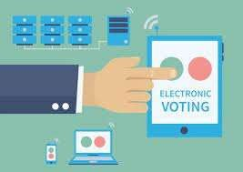In a democracy, a government is chosen by voting in an election a way for an electorate toelect, i.e., choose, among several candidates for rule.[1]However, more than likely, elections willbe between two opposing parties. These two will be the most established and the most popular.For example, in the US the competition is between the Republicans and the Democrats. In anindirect democracy *voting* is the method by which the person elected (in charge) represents theirpolicies and party, whilst making decisions, with regards to other authorities. For example, in theUK the prime minister has to make decisions with regards to the House of Commons and HouseofLords.Directdemocracy,isthecompleteopposite,thepersonelected,hasmoreindependentcontrolanddoesnotneedtogetpoliciespassedthroughoutthegovernment.

Figure1.1Electronicvoting

Figure1.1ElectronicVotingisthestandardmeansofconductingelectionsusingElectronicVoting machines,sometimes called “EVMs inIndia. They were introduced inIndian elections between 1998and 2001, in a phased manner. Prior to the introduction of electronic voting, India used paper ballots andmanualcounting.

In retrospect, a majority vote is when the mass of individual's vote for the same person. However,whilst each individual’s choice for or against, does count, a lot of countries use geographic measures todecidewhowins.Forexample,intheUKthepersonwiththemostconstituencieswin,buttheymaynotalwayshavethemostindividualvotes.Othercountrieswhohaveliberaldemocracies,mayusea secret ballot, hoping to prevent individuals from becoming influenced by other people and to protecttheir political privacy. The objective for secret ballots, is to try and get the most authentic outcome. Areasoningbehindwhythiswayofvotingmaycapturea betterresult,ismainlytodowithsocialinfluence.

**1.2 LITERATURE SURVEY**

**[1]** Research paper on: **“Smart and Secure Voting Machine Using Biometrics (SEPTEMBER 2020)”**

In core topic of this system is biometrics. There is a big total of populations who are appropriate to vote are called as voters, in India to identify each voter, a unique number is provided with the voter id. Besides, for verification purposes, biometrics traits can be used. A fingerprint is unique to each human being, which provides much better protection than any secret keywords or passes keys. Thus, the biometric concept can provide a better-protected system for polling. In EVM there is no module that can confirm if the citizen’s vote cast or not. So, the paper is proposed to include an SMS module and GSM module to confirm the vote cast by the voter is registered via a confirmation message to the registered mobile phone. This will improve the consistency and proficiency of the system.

The proposed system has a double verification for a more secure system. This system uses a cloud database; hence it will be more efficient than the existing system. There is additional GPS in the system, this will prevent the system from theft if the system is stolen it can be located easily and immediately through satellites. Through GSM, we can get a confirmation message about to which candidate the vote got registered to, this way the elector can verify that the voter is pitched to his favorite’s candidate.

**[2]** Research paper on: **“Arduino Based Secure Electronic Voting System with IoT and Pub Nub for Universities (JULY 2020)”**

Internet of Things (IOT) is the network of integrated physical devices that are set with connectors, actuator and communication media that allow them to send and receive data over the internet [1]. This technology is simplifying the lives of people and making everything easier day by day in every walk of life [2]– [4]. The use of IoT in elections also improves the voting procedures. This system also looks after for the number of functional and non-functional requirements which are very important in every phase of system design.

The precision, reliability and efficiency of the voting process will also be greatly increased and the overall time to declare the results of the elections will also be reduced. There are basically two types of online voting developed; one which is deployed at polling stations and it is officially supervised by the officer of electoral authorities. The second is remote online voting system which is connected with the internet and voter can submit their vote electronically from any location. The second technology of casting vote from any location can greatly increase the overall turnout of the voters for the voting process.

This technology is very useful for those people who are living far away from polling stations and they cannot go to polling stations to cast their vote. By the use of IoT this system is very easy to use and maintain and it will also provide the capability of handling various modules at various centers and will provide efficient scalability for larger elections. The overall performance of online voting system is based on its user interface, usability and security. Top of line security measure in online system make them more advanced and robust.

**[3]** Research paper on: **“A Survey on Smart Electronics Voting System Through Block Chain Technology (APRIL 2020)”**

In this system Block Chain Concepts are applied to Online Voting System when we are developing a Smart E-voting system by taking advantage of block Chain concepts with web Interface. In this we are using 2 modules i.e. Admin and Voter Module 1 - Administrator (Admin): - Admin Add Candidate, Candidate details and check user(Voter) are legal or not. Module 2 - User (Voter): - Voter can cast the vote to the candidate.

This paper described, an electronic Voting system for small to medium sized Internet-based public opinion systems that provides privacy of vote, voter’s authentication, auditability, double-voting prevention, fairness voting device from manipulating the authenticated voters voting choices.

In this paper, used of Aadhar card provided by UIDAI with QR code present in it. Online instead of offline mode and storing the voting data to secured online server. Results can be

displayed by admin after entering user id and password.

**[4]** Research paper on: **“Towards The Intelligent Agents for Block Chain E-Voting System (2018)”**

There are many existing voting solutions which have different benefits and issues. The most significant ones are lack of transparency and auditability. Recently developed block chain technology may be a solution to these issues. The paper describes the use of intelligent agents and multi-agent system concept for Auditable Block Chain Voting System (ABVS), which integrates e-voting process with block chain technology into one supervised non-remote internet voting system which is end-to-end verifiable.

Block chain technology can provide a solution to some of these problems. One of the properties of block chain is an ability to create a platform for a public verification of data stored inside. Utilizing this characteristic of block chain technology allows for a possibility of the creation of an e-voting system which can be audited by common voters instead of dedicated institutions and officials. Recognizing a great opportunity, some countries already started re-searching and implementing block chain-based e- voting systems

**[5]** Research paper on: **“Blockchain-Enabled E-Voting (2018)”**

Block chain-enabled e-voting (BEV) could reduce voter fraud and increase voter access. Eligible voters cast a ballot anonymously using a computer or smartphone. BEV uses an encrypted key and tamper-proof personal IDs. This article highlights some BEV implementations and the approach's potential benefits and challenges.

E-voting is among the key public sectors that can be disrupted by block chain technology.1 The idea in block chain-enabled e-voting (BEV) is simple. To use a digital-currency analogy, BEV issues each voter a “wallet” containing a user credential. Each voter gets a single “coin” representing one opportunity to vote. Casting a vote transfers the voter’s coin to a candidate’s wallet. A voter can spend his or her coin only once. However, voters can change their vote before a present deadline

**[6]** Research paper on: **“Multi-Purpose Platform Independent Online Voting System (2017)”**

The system that we initiate mainly focuses on voting system that will enhance the voting more secure and authenticated in future. As there is exponentially growth in the number of Smartphone users, we may say majority of the world population will own a Smartphone in future. Thereby we propose a system which will work on any operating system be it windows, android or IOS using the QR code and OTP (one-time password functionality embedded in them.In this system the user can create their own voting ballot. This same system can be utilized for many other scenarios as well. For instance, election can be conducted for various private and public organizations; government can conduct election through our system hereby making the system more feasible to use for the user. By encrypting the vote data to the user’s end and decrypting to the local administrator i.e. which creates the voting ballot. This would make the system more secure and authenticated.

**[7]** Research paper on: **“Pressing the Button for European Elections (2014)”**

Electronic voting systems are deemed as a cost-effective alternative for conducting elections, having a promising potential for the quality of democratic representation especially among distinct social groups that may face difficulties accessing polling stations. Yet studies investigating the acceptance of e-voting [1] by the general public remain scarce. This paper advanced the literature on electronic voting by presenting evidence on attitudes toward electronic voting from Greece. Three main conclusions can be drawn from the analysis.

First, our results point to the conclusion that acceptance of electronic voting could be fairly high in the general population, bringing additional evidence to confirm previous research by [2] and [3]. This finding however should be interpreted with caution as the sample was skewed in regard with age and level of education, compared to the general Greek population. An additional parameter that may have boosted positive responses is that respondents took part in the trial after having tried the e-voting device. Second, the aggregate distribution of preferences toward e-voting masks significant individual-level variation: Citizens who are already familiar with technology, those who found e-voting easy and older age cohorts were significantly more likely to be supportive of its implementation in national elections.

These results appear to substantiate the worry that the advent of electronic voting could possibly create a gap between segments of the population who are familiar with technology and those who are not. On the other hand, gender and education were unrelated to e-voting preference. Third, sociodemographic characteristics and familiarity with technology account only for a small portion of the total variation in acceptance of electronic voting.

**[8]** Research paper on: **“Electronic Voting Machine-A Review (MARCH 2012)”**

There have been several studies on using computer technologies to improve elections [3, 20, 12, 14, and 16]. These studies caution against the risks of moving too quickly to adopt electronic voting machines because of the software engineering challenges, insider threats, network vulnerabilities, andthe challenges of auditing. Electronic voting machine is a simple machine that can be operated easily by both the polling personnel and the voters. Being a standalone machine without any network connectivity, nobody can interfere with its programming and manipulate the result. Keeping the erratic power supply position in many places in the country, the machines have been made to run on batteries.

It has mainly two units: Control unit and Ballot unit. The Control Unit is the main unit which stores all data and controls the functioning of EVM. The program which controls the functioning of the control unit is burnt into a microchip on a “one-time programmable basis”. Once burnt it cannot be read, copied out or altered. The EVMs use dynamic coding to enhance security of data transmitted from ballot unit to control unit .Although there has been cryptographic research on electronic voting [7], and there are new approaches such as [4] currently the most viable solution for securing electronic voting machines is to introduce a “voter-verifiable audit trail” [6, 12]. A verifiable audit trail does not, by itself, address voter privacy concerns, ballot stuffing, or numerous other attacks on elections.

Some vendors have claimed “security through obscurity” as a defense, despite the security community’s universally held belief in the inadequacy of obscurity to provide meaningful protection. [4]. Electronic voting: It is also known as e-voting is a term encompassing several different types of voting, embracing both electronic means of casting a vote and electronic means of counting votes. Electronic voting technology can include punched cards, optical scan voting systems and specialized voting kiosks (including self-contained direct-recording electronic voting systems, or DRE). It can also involve transmission of ballots and votes via telephones, private computer networks, or the Internet. And, of course, EVM helps maintain total voting secrecy without the use of ballot papers. And, at the end of the polling, just press a button and there you have the results.

**LITERATURE SURVEY:**

**TABLE 1.1 LITERATURE SURVEY**

|  |  |  |  |  |  |  |
| --- | --- | --- | --- | --- | --- | --- |
| **S.**  **No:** | **NameoftheAuthor** | **PaperTitle** | **InternationalJournal/conference** | **Month**  **/Year** | **Description** | **Limitations/Drawbacks** |
| 01. | A.Bala Murali | SmartandSecureVotingMachineusingBiometrics | Proceedingsofthe FourthInternationalConferenceonInventivesystemsandControls | September2020 | LEDsareusedasthesourceoflight.Thebasicprinciplebehindtheworkingofthistechnologyis–iftheLEDisON,digitalHIGHwillbetransmittedandifLEDisOFF,digitalLOWwillbetransmitted. | Asthedistancebetweenthetransmitterandreceiverincreases,thereceivedsignalqualitydecreases. |
| 02. | Mr. SantoshKumar | AsurveyOnSmart | JournalOfEmerging | April2020 | Li-FiistransmissionofdatausingvisiblelightbysendingdatathroughanLEDlightbulbthatvariesinintensityfasterthanthehumaneyecanfollow. | ThereceiveddataisaffectediftheanglebetweenthereceiverandLOSoftheLEDchanges. |
|  |  | Electronic | Technologies |  |
|  |  | VotingSystem | AndInnovative |  |
|  |  | ThroughBlock | Research |  |
|  |  | Chain | (IJTSRD) |  |
|  |  | Technology |  |  |

|  |  |  |  |  |  |  |
| --- | --- | --- | --- | --- | --- | --- |
| **S.**  **No:** | **NameoftheAuthor** | **PaperTitle** | **InternationalJournal/conference** | **Month**  **/Year** | **Description** | **Limitations/Drawbacks** |
| 03. | K.CArun | ArduinoBased | 4thGlobal | July  2020 | TheuseoffastpulsesoflighttotransferdatawithoutphysicalconnectionsuchmethodiscalledasVisiblelightcommunication(VLC).Thisprocessisdoneinthis.ThisprojectdescribesandimplementsthedesignofLi-Fiaudiotransmissionsystem. | LineofSightismandatorybetweentransmitterandreceiverifitlosescommunicationisnotdone. |
|  |  | Secure | Conferenceon |  |
|  |  | Electronic | Computing& |  |
|  |  | VotingSystem | Media |  |
|  |  | WithIoTand | Technology |  |
|  |  | PubNubfor |  |  |
|  |  | Universities |  |  |
| 04. | NikKshetriJeffreyVoas | BlockChain-EnabledE-Voting | IEEE | 2018 | Li-FiworksontheprincipleofVisibleLightCommunication(VLC).Itusesthevisiblespectrumaswellasultravioletandinfraredradiations.Thiskindofcommunicationisverycheapandeasytomaintain. | IncaseofLi-Fi,iflightgetsobstructedduetoanyphysicalobject,communicationisnotdone. |

|  |  |  |  |  |  |  |
| --- | --- | --- | --- | --- | --- | --- |
| **S.**  **No:** | **NameoftheAuthor** | **PaperTitle** | **InternationalJournal/conference** | **Month**  **/Year** | **Description** | **Limitations/Drawbacks** |
| 05. | Michal | Towardsthe | The9th | 2018 | Li-Fiisthe | Thelightwaves |
|  | Pawlak, | Intelligent | International |  | termsomehave | cannot |
|  | Aneta | Agentsfor | Conferenceon |  | usedtolabel | penetratewalls |
|  | Poniszewka- | BlockChain | Emerging |  | thefastand | whichmakesa |
|  | Maranda, | E-Voting | Ubiquitous |  | cheapwireless | muchshorter |
|  | Natalia | System | Systemand |  | communication | range. |
|  | Kryvinska |  | Pervasive |  | system,which |  |
|  |  |  | Networks |  | istheoptical |  |
|  |  |  | (EUSPN) |  | versionofWi- |  |
|  |  |  |  |  | Fi.Li-Fiuses |  |
|  |  |  |  |  | visiblelight |  |
|  |  |  |  |  | insteadof |  |
|  |  |  |  |  | Gigahertzradio |  |
|  |  |  |  |  | wavesfordata |  |
|  |  |  |  |  | transfer. |  |
| 06. | Dr.Z.A  Usmani,KaifPatanwala | Multi-PurposePlatformIndependentOnlineVotingSystem | ICIIECS | 2017 | TheuseofLi-Fiinthevoiceanddatatransmissionandinhome/officeautomationincreasesthespeedofoperationofvoiceanddatatransmission.UseofLi-Fiismoresecure,speedyandcheapcommunication. | Forlongdistancecommunicationthelightintensityisrequiredmorethannecessary. |

|  |  |  |  |  |  |  |
| --- | --- | --- | --- | --- | --- | --- |
| **S.**  **No:** | **NameoftheAuthor** | **PaperTitle** | **InternationalJournal/conference** | **Month**  **/Year** | **Description** | **Limitations/Drawbacks** |
| 07. | AlexDelis,KonstantinaGavatha, | PressingthebuttonforEuropeanelections | InternationalConferenceonElectronicvotingEVOTE | 2014 | Thisprojectistomakesystemfordatatransferinindoorunitwithouttheusageofradiowaves. HerewedeveloptheapplicationmoduleofLi-Fitechnology.InwhichdatacantransmitthroughLEDandreceivebyusingphotodiode. | Communicationisdonedependingupontheintensityofthelight. |
| 08. | D.AshokKumar,T.UmmalSaribaBegum | ElectronicVotingMachine-AReview | InternationalConferenceonPatternRecognition,InformaticsandMedicalEnginnering | 2021 | Toshowthatsignificantimprovementsofindoordatacoveragecanbeexpectedfromanopticalattocellnetwork.ThisconceptisbasedondatatransmissionviaopticalfiberandLED. | InterferenceCo-ordination. |

**1.3 THESIS OUTLINE**

**CHAPTER 1:**

In Introduction chapter we have discussed about objective of the project i.e., Voting system. We have discussed about the works and Literature Surveys which are done on this project. We have briefly explained the works and researches which are done before on this project.

**CHAPTER-2**

**EXISTING-SOLUTON**

**2.1 INTRODUCTION TO THE PROJECT:**

Electronic Voting Machine (also known as EVM) is voting using electronic means to either aid or take care of the chores of casting and counting votesEVM is designed with two units: the control unit and the balloting unit. These units are joined together by a cable. The control unit of the EVM is kept with the presiding officer or the polling officer. The balloting unit is kept within the voting compartment for electors to cast their votes. This is done to ensure that the polling officer verifies your identity. With the EVM, instead of issuing a ballot paper, the polling officer will press the Ballot Button which enables the voter to cast their vote. A list of candidate’s names and/or symbols will be available on the machine with a blue button next to it. The voter can press the button next to the candidate’s name they wish to vote for.

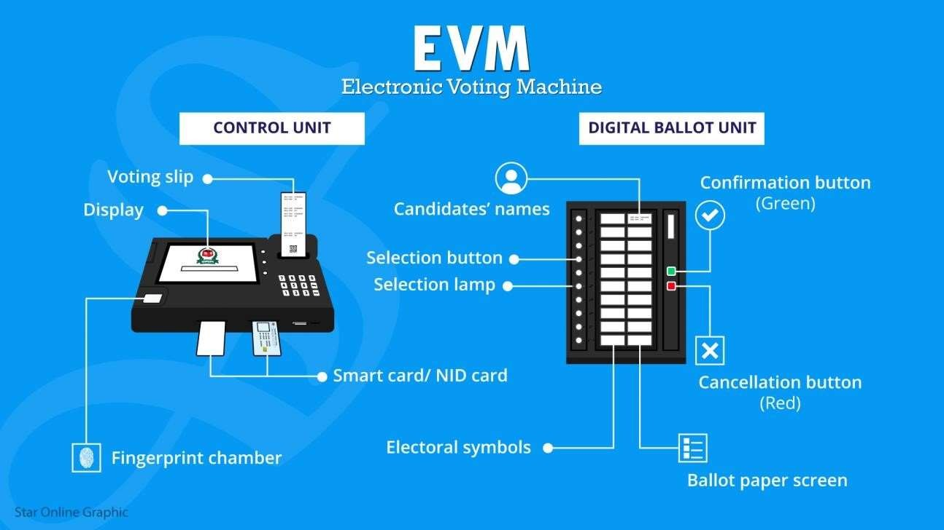

Fig2.4ElectronicVotingMachine

Fig 2.4 represents Electronic Voting Machine (EVM) it consists of two parts Control unit and Digital Ballot unit.

The current electronic voting machines in India are the M3 version with VVPAT capability, the older versions being M1 and M2. They are built and encoded with once-write software (read-only masked memory) at the state-owned and high-security premises of the Bharat Electronics Limited and the Electronics Corporation of India Limited. [4] [35] The inventory of election EVMs is securely tracked by the Election Commission of India on a real-time basis with EVM Tracking Software (ETS). This system tracks its digital verification identity and physical presence. The M3 EVMs has embedded hardware and software that enables only a particular control unit to work with a particular voting unit issued by the Election Commission, as another layer of tamper-proofing. Additional means of tamper proofing the machines include several layers of seals. Indian EVMs are stand-alone non-networkedmachines. [36] [37].

The EVM was designed by two professors of IIT Bombay, A.G. Rao and Ravi Poovaiah.[31] An EVM consists of two units, a control unit, and the balloting unit. [32] The two units are joined by a five- meter cable. Balloting unit facilitates voting by a voter via labelled buttons while the control unit controls the ballot units, stores voting counts and displays the results on 7 segment LED displays. The controller used in EVMs has its operating program etched permanently in silicon at the time of manufacturing by the manufacturer. No one (including the manufacturer) can change the program once the controller is manufactured. The control unit is operated by one of the polling booth officers, while the balloting unit is operated by the voter in privacy. The officer confirms the voter's identification then electronically activates the ballot unit to accept a new vote. Once the voter enters the vote, the balloting unit displays the vote to the voter, records it in its memory. A "close" command issued from the control unit by the polling booth officer registers the vote, relocks the unit to prevent multiple votes. The process is repeated when the next voter with a new voter ID arrives before the polling booth officer. [32]

An EVM can record a maximum of 3840 (now 2000) votes and can cater to a maximum of 64 candidates. There is provision for 16 candidates in a single balloting unit and up to a maximum of 4 balloting units with 64 candidate names and the respective party symbols can be connected in parallel to the control unit. [32]

**2.2 BLOCK CHAIN TECHNOLOGY:**

Block chain technology fixed shortcomings in today’s method in elections made the polling mechanism clear and accessible, stopped illegal voting, strengthened the data protection, and checked the outcome of the polling. The implementation of the electronic voting method in block chain is very significant [35]. However, electronic voting carries significant risks such as if an electronic voting system is compromised, all cast votes can probably be manipulated and misused. Electronic voting has thus not yet been adopted on a national scale, considering all its possible advantages.

Today, there is a viable solution to overcome the risks and electronic voting, which is block chain technology. In Figure, one can see the main difference between both of the systems. In traditional voting systems, we have a central authority to cast a vote. If someone wants to modify or change the record, they can do it quickly; no one knows how to verify that record. One does not have the central authority; the data are stored in multiple nodes. It is not possible to hack all node sand change the data. Thus, in this way, one cannot destroy the votes and efficiently verify the votes by tally with other nodes.

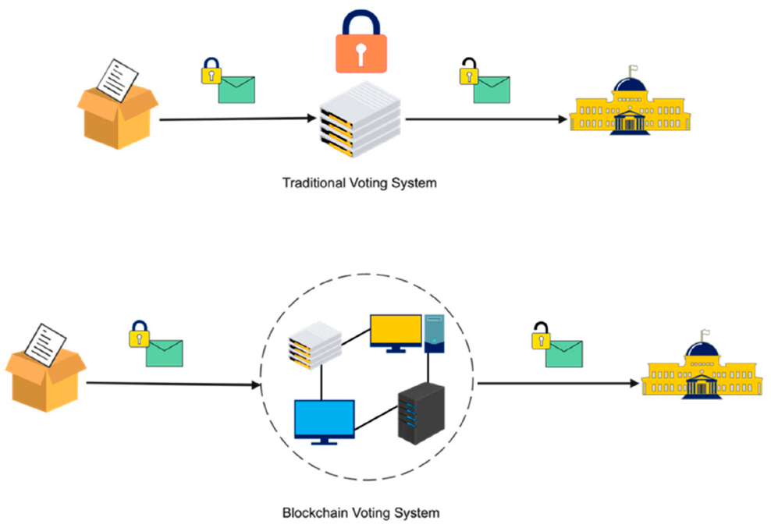

Fig 2.1 Block chain Technology

Fig 2.1 represents how information is Traditional vs. block chain technology, in traditional voting systems, we have a central authority to cast a vote. If someone wants to modify or change the record, they can do it quickly; no one knows how to verify that record. One does not have the central authority; the data are stored in multiple nodes. It is not possible to hack all nodes and change the data. Thus, in this way, one cannot destroy the votes and efficiently verify the votes by tally with other nodes.

**2.2.1 REAL TIME SYSTEMS:**

Electronic Voting Machine (EVM) is a simple electronic device used to record votes in place of ballot papers and boxes which were used earlier in conventional voting system. Fundamental right to vote or simply voting in elections forms the basis of democracy. All earlier elections be it state elections or centre elections a voter used to cast his/her favorites candidate by putting the stamp against his/her name and then folding the ballot paper as per a prescribed method before putting it in the Ballot Box.

This is a long, time-consuming process and very much prone to errors. This situation continued till election scene was completely changed by electronic voting machine. No more ballot paper, ballot boxes, stamping, etc. all this condensed into a simple box called ballot unit of the electronic voting machine. Because biometric identifiers cannot be easily misplaced, forged, or shared, they are considered more reliable for person recognition than traditional token or knowledge based methods. So the Electronic voting system has to be improved based on the current technologies viz., biometric system. This article discusses complete review about voting devices, Issues and comparison among the voting methods and biometric EVM.

Ballot papers:

A ballot is a device used to cast votes in an election and may be found as a piece of paper or a small ball used in secret voting. [1] It was originally a small ball (see blackballing) used to record decisions made by voters in Italy around the 16th century. [2]

Each voter uses one ballot, and ballots are not shared. In the simplest elections, a ballot may be a simple scrap of paper on which each voter writes in the name of a candidate, but governmental elections use pre-printed ballots to protect the secrecy of the votes. The voter casts their ballot in a box at a polling station.

In British English, this is usually called a "ballot paper”. [3] The word ballot is used for an election process within an organization (such as a trade union "holding a ballot" of its members).

• In a jurisdiction using a paper system, voters choose by marking a ballot or, as in the case of Israel and France, picking one pre marked ballot from among many. In most jurisdictions the ballots are pre-printed with names of candidates and the text of the referendums. The Philippines (until 2007) and Japan are an exception. There, voters must write the names of their candidates on the ballot.[12] Election officials manually count the ballots after the polls close and may be recounted in the event of a dispute.

• In a jurisdiction using an optical scan voting system, voters choose by filling an oval or by completing an arrow on the printed ballot next to their chosen candidate or referendum position. Voters with disabilities may be provided with electronic ballot marking devices. Optical scan technology has also been used by many standardized tests. Tabulating machines count the ballots either after the polls close or as the voters feed the ballots into the machine, in which case the results are not known until after the polls close. Officials often will manually count any ballots that cannot be read or with a write-in candidate and may recount the ballots in the event of a dispute.

• In a jurisdiction using a punched card system, voters choose by removing or "punching out" a perforated Chad from the ballot next each choice, sometimes with tools as simple as a pin, but usually with a ballot marking device such as the Voto-matic. The ballot may be pre-printed with candidates and referendums, or may be a generic ballot placed under a printed list of candidates and referendums. Tabulating machines count ballots after the polls close. Officials may manually count the ballots in the event of a dispute. Punched card voting systems are being replaced by other voting systems because of a high rate of inaccuracy related to the incomplete removal of the perforated chad and the inaccessibility to voters with disabilities.

• In a jurisdiction using a mechanical voting system, often called a "voting machine", voters choose by pulling a lever next to their choice. There is a printed list of candidates, parties and referendums next to the levers indicating which lever is assigned to which choice. When the voter pulls a lever, it turns a connected gear in the machine, which turns a counter wheel. Each counter wheel shows a number, which is the number of votes cast using that lever. After the polls close, election officials check the wheels' positions and record the totals. No physical ballot is used in this system, except when the voter chooses to write-in a candidate. Other systems are replacing mechanical voting systems because they are inaccessible to disabled voters, do not have a physical ballot and are getting old.

• In a jurisdiction using an electronic direct record voting system (DRE), voters choose by pushing a button next to a printed list of candidates and referendums, or by touching the candidate or referendums box on a touchscreen interface. As the voter makes a selection, the DRE creates an electronic ballot stored by in the memory components of the system. After the polls close, the system counts the votes and reports the totals to the election officials. Many DREs include a communication device to transmit vote totals to a central tabulator. The touchscreen systems remind people of an automated teller machine (ATM) and often are described as such.

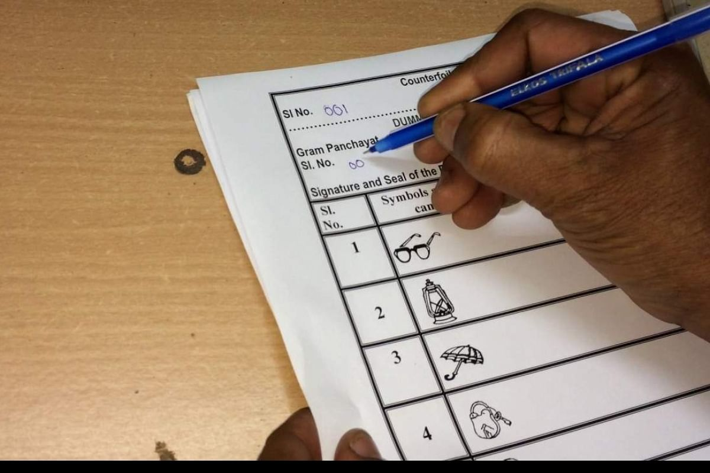

Fig2.2Ballotpaper

Fig 2.2 represents ballot paper it explains how people used to elect the representatives in the election. They need to mark the candidate to whom they wanted to choose in the election on their choice. Voting Machines:

A voting machine is a machine used to record votes without paper. The first voting machines were mechanical but it is increasingly more common to use electronic voting machines. Traditionally, a voting machine has been defined by its mechanism, and whether the system tallies votes at each voting location, or centrally. Voting machines should not be confused with tabulating machines, which counts votes done by paper ballot. Voting machines differ in usability, security, cost, speed, accuracy, and ability of the public to oversee elections. Machines may be more or less accessible to voters with different disabilities.

Tallies are simplest in parliamentary systems where just one choice is on the ballot, and these are often tallied manually. In other political systems where many choices are on the same ballot, tallies are often done by machines to give quick results.

Each voter was to cast his vote by dropping a brass ball into the appropriate hole in the top of the machine by the candidate's name. Each voter could only vote once because each voter was given just one brass ball. The ball advanced a clockwork counter for the corresponding candidate as it passed through the machine, and then fell out the front where it could be given to the next voter.

Bernanke’s machine presented an array of push buttons to the voter, with one row per office on the ballot, and one column per party. Interlocks behind each row prevented voting for more than one candidate per race, and an interlock with the door of the voting booth reset the machine for the next voter as each voter left the booth.

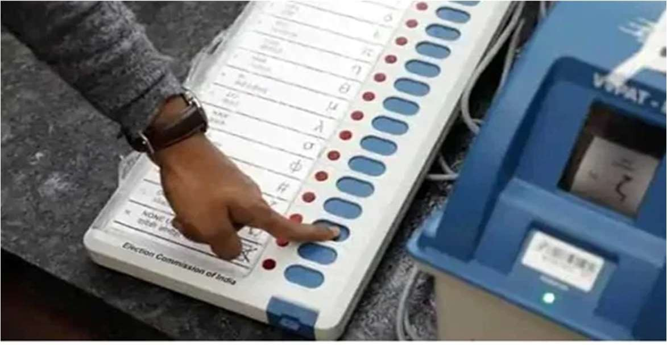

Figure 2.3 Voting Machine

Fig 2.3 represents Voting Machine in which the voter need to pull the button so that his/her vote will be recorded. By pushing the button voter can elect their representative.

Electronic Voting system using block chain technology:

Block chain is a technology that is rapidly gaining momentum in era of industry 4.0. With high security and transparency provisions, it is being widely used in supply chain management systems, healthcare, payments, business, IoT, voting systems, etc.

Current voting systems like ballot box voting or electronic voting suffer from various security threats such as DDoS attacks, polling booth capturing, vote alteration and manipulation, malware attacks, etc., and also require huge amounts of paperwork, human resources, and time. Some of the disadvantages are:

* Long Queues during elections
* Security Breaches like data leaks, vote tampering.
* Lot of paperwork involved, hence less eco-friendly and time-consuming.
* Difficult for differently-abled voters to reach polling booth.
* Cost of expenditure on elections is high.

Suppose you are an eligible voter who goes to polling booth and cast vote using EVM (Electronic Voting Machine). But since it’s a circuitry after all and if someone tampers with microchip, you may never know that did your vote reach to person for whom you voted or was diverted into another candidate’s account? Since there’s no tracing back of your vote. But, if you use block chain- it stores everything as a transaction that will be explained soon below; and hence gives you a receipt of your vote (in a form of a transaction ID) and you can use it to ensure that your vote has been counted securely.

Now suppose a digital voting system (website/app) has been launched to digitize process and allit, he/she can change candidate’s vote count- from 2 to 22! You may never know that hacker installs malware or performs clickjacking attacks to steal or negate your vote or simply attacks central server.

To avoid this, if system is integrated with block chain- a special property called immutability protects system. Consider SQL, PHP, or any other traditional database systems. You can insert, update, or delete votes. But in a block chain you can just insert data but cannot update or delete. Hence when you insert something, it stays there forever and no one can manipulate it- Thus name immutable ledger. But building a block chain system is not enough. It should be decentralized i.e., if one server goes down or something happens on a particular node, other nodes can function normally and do not haveto wait for victim node’s recovery.

So, a gist of advantages is listed below:

You can vote anytime/anywhere (During Pandemics like COVID-19 where it’s impossible to hold elections physically

* Secure
* Immutable
* Faster
* Transparent

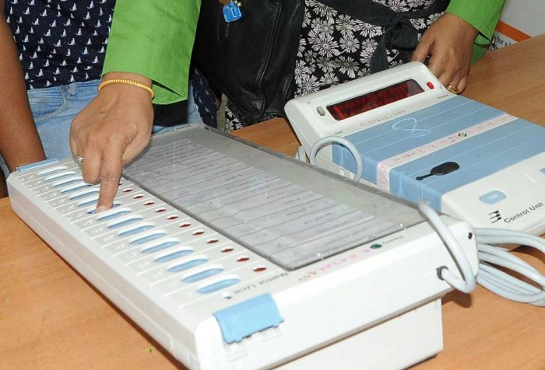

Fig 2.3 Voting system

Fig 2.3 represents Voting system how the people chosen their representatives in earlier days it explains. Casting of vote is shown on the screen to the voter so that he/she able to understand whether he/she given their vote or not.

**2.3 EXISTING SYSTEM:**

The existing solution which includes a GSM module, SMS module, GPS, fingerprint sensor and an image scanner. This makes the system more secure and efficient than the current existing EVM. We use biometrics technology to identify the valid voter from the database which has the voter’s details with his fingerprints. With the help of the GSM module and SMS unit, the message is notified to a valid citizen's portable device that he has effectively made the choice. So he can check effectively with no disarray. The given system also involves the Global Positioning System, which provides the Geographical location of the given system is located. The GPS module provided with the system helps in tracking the device in the case of stealing the device from the polling booth.

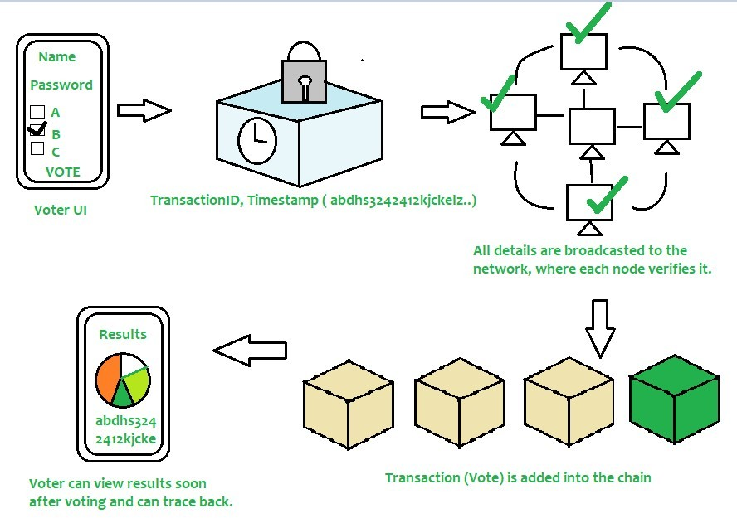Considering that the cloud is coupled with the system, the system can act as an online system. In this proposed system the flaws of EVM are overcome. This system is much better protected and work with higher efficiency than the system that is already present. This system includes a database that has a list of the voters who have cast their votes. This list is provided in order to determine the voters one’s who wasted their valuable chance to decide the rightful candidate representative and the corresponding steps or measures can be taken regarding these default voters.

Fig 2.4 Voting System Using Block Chain Technology

Fig 2.2 represents, according to above diagram, voter needs to enter his/her credentials in order to vote. All data is then encrypted and stored as a transaction. This transaction is then broadcasted to every node in network, which in turn is then verified. If network approves transaction, it is stored in a block and added to chain. Note that once a block is added into chain, it stays there forever and can’t be updated. Users can now see results and also trace back transaction if they want.

Since current voting systems don’t suffice to security needs of modern generation, there is a need to build a system that leverages security, convenience, and trust involved in voting process. Hence voting systems make use of Block chain technology to add an extra layer of security and encourage people to vote from anytime, anywhere without any hassle and makes voting process more cost- effective and time-saving.

**2.4 BRIEF SUMMARY OF EXISTING SOLUTION:**

Voting is complex process which required high transparency. We have proposed Arduino microcontroller based secure electronic voting system for universities. This system used Pub Nub cloud computing platform for security and analysis. This an advanced and robust system, in which all the data related to voting is stored in the form of digital information in cloud which makes it fully secure from traditional ballot paper-based voting. A prototype was implemented to show the working and performance of system.

This system will surely ensure a more secure and safer method of voting for elections in universities. Our future plans are to amplify the research of fingerprint voting system to multi-biometric voting system in which we will integrate facial recognition, retina scan and iris scan technology. This paper described, an electronic Voting system for small to medium sized Internet-based public opinion systems that provides privacy of vote, voter’s authentication, auditability, security, double-voting prevention, fairness voting device from manipulating the authenticated voters voting choices.

**2.5 PROPOSED SYSTEM:**

E-voting system helps the user to cast the vote without visiting the polling booth. We have two voting types I-Voting and SMS-Voting where as I-Voting (Internet Voting) is done remotely via internet. SMS-Voting is done by sending SMS to the Election Department.

In the first step the registration process is done by the voters through an application. Then in the second step the application will start its process. Here we use already existed database or centralized database, which contains voter’s information with linked mobile number. Server sends the OTP (One-Time Password) to the voter’s registered mobile number. Then voter enters that OTP, then database again verifies that entered OTP by voter and if it is correct that means he/she is a valid user. Face recognition will have done here if the data matches with database it will go to next step. After the Face recognition candidate’s list will appears. This list contains the candidate name and in front of that name the button named ‘Vote’ is provided. Voter should have to press that button then only the voting is done and the voting procedure is completed.

We are using block chain technology we build block chain using python 3.7 programming language in this project.

These include:

* Easier access to debuggers through a new break point () built-in
* Simple class creation using data classes
* Customized access to module attributes
* Improved support for type hinting
* Higher precision timing functions
* More importantly, python 3.7 is fast and it is officially when compared to other latest versions of python.



Fig.2.4 Facial Recognition

Fig 2.4 represents the main object of our project facial recognition technology which is used in our project. As block chain is used in earlier days also but here, we have added facial recognition using python 3.7 we are doing the project.

Here we can access with the data which is present already or we can add new data in to data base. It is secure, more helpful to the people who are living in another countries, no need to stand in the queues Citizens can cast their vote from the place where they are.

Facial recognition is a way of recognizing a human face through technology. A facial recognition system uses biometrics to map facial features from a photograph or video. It compares the information with a database of known faces to find a match. Facial recognition can help verify a person’s identity, but it also raises privacy issues.

In the real world, though, accuracy rates are usually lower. According to the CSI story, the Facial Recognition Vendor Test found that the error rate for one algorithm rose from 0.1% when faces were matched against high-quality mugshots to 9.3% when matched to pictures of individuals captured in public.

You might be good at recognizing faces. You probably find it a cinch to identify the face of a family member, friend, or acquaintance. You’re familiar with their facial features — their eyes, nose, mouth — and how they come together. That’s how a facial recognition system works, but on a grand, algorithmic scale. Where you see a face, recognition technology sees data. That data can be stored and accessed.

**2.6 ADVANTAGES AND DISADVANTAGES OF VARIOUS VOTING SYSTEMS:**

**Table 2.1: Differences between Li-Fi and Wi-Fi**

|  |  |  |
| --- | --- | --- |
| **Votingsystem** | **Advantages** | **Disadvantages** |
| PaperBallotVotingSystem | **Ease:**PaperBallotVotingSystemisthemostcommonandeasiestwayforthevoterstocasttheirvotes.  Uneducatedpeoplecanalsovotewithease.  **LessCostly:**Asthereisnoexternaldeviceandresourcesinvolvesoitiscosteffectiveonlythehumanresourcesarerequiredasthevotersdoesn’thavetopayanything**Portable:**Thisvotingsystemcanbecarriedouteasilyatanyplacewiththe  helpofmanpower. | **MoreTimeConsuming:**Itisaverysluggishprocess.AsvotershavetostandinalongqueueandonlySinglevoterisallowtovoteatonetime.  **LessSecure:**Thevotingboothcanbehijackedbypoliticalparties.Thisisknownaselectionscamswhichwereseeninmanycases.  **LowEvaluationSpeed:**It  takesmoretimetogetresults. |
| E-Votingsystem | **Flexibility**:Sincethesystemworksonelectronicdeviceswiththefewchangingonthedesignthesedevicescanbeusedforvariousballotformats.**CostEffective**:ItisreasonableasE-Votingsystemisaonetimeinvestment.Laterexpensescanberecovered.  **FastComputationalSpeed:**AsthisisanE-VotingSystemtheresultswouldbedeclaredpromptassoonasthevotingisover. | **Vulnerable:**Astherecanbeanyexternalthreatonthesystem.MorePower**Utilization:**Astheseisaelectronicdevicethusrequiresmoreelectricity.  ThereareplaceswhichlackelectricitysoovertheirE-VotingSystemisnotagoodoptionastheElectronicdevicebatteryexhaustfast.**Expensive:**E-Voting Systemisanexpensivedevice.EachUnitofthisdevicemaycost  around$200-$300. |

|  |  |  |
| --- | --- | --- |
| InternetVotingSystem | **Mobility**:AsthissystemworksonInternetitcanbeaccessedfromanypartof theglobe.  **Swift**:Thissystemworksfasterbecauseatthesametimemultiplevoterscanvote.Thevoterscanvoteusinganapplicationontheirthusnotmakingthemstandinaqueue.  **Reutilize:**Thesystemcanbereutilizedagainwithnominalchangesinthesystem. | **Complexity**:Theuserinterfaceiscomplextherebymakingtheuserdifficulttounderstandtheconceptofinternetvoting.  **HighCost**:InternetVotingSystemismoreexpensivethanothervotingsystems.Thesystemiscostlybecausetherearehardwareandsoftwarerequirementswhich  needtobefulfilled |
| SMSandCallsVotingSystem | **Flexibility**:Suchsystemcanbealteredaspertherequirementsoftherealityshows,suchavotingsystemisquite elastic.  **FastComputation**:Asthevotecountsaredonebymachinesinsteadofhumanbeing.Thusresultinginfastercountsof vote | **Noexceptionality**:AUserhavingtwosimcardscanvotetwiceforthesamecandidateasaresult,thereisnowaywhetherthesystemcanrecognizewhethertheuserhasvotedornot.  **Intricate design:**The designofthesystemisquitecomplicatedcomparedto  anothervotingsystem |

**CHAPTER-3**

**SYSTEM ANALYSIS AND DESIGN**

**3.1 EXISTINGSYSTEM:**

Blockchain is a distributed record database, often called a ledger. The key assumption is that the records that are previously written in blocks are immutable. Advanced encryption is utilized to ensure that blocks are chained and data integrity is guaranteed. The type of network connectivity is another feature. Client client technique communicates with network nodes. No third party is able to communicate between customers and hence there is no need for trust. The real identity of the network participant is unknown [3]. We will explore various existing solutions for blockchain-based e-voting systems.

**LIMITATIONS**

Only in the last ten years are electronic voting systems popular and unresolved. E-voting schemes pose mainly safety, credibility, openness, reliability and functionality challenges. Estonia is the pioneer and the state-of-the-art in this subject. But with blockchain there are just a few solutions.

Blockchain can offer a response to all of the difficulties above and also offer certain benefits such as immutability and decentralization. The key challenges with blockchain technology for e-voting include focusing on just one subject or the absence of testing and comparison.

**3.2 PROPOSED SYSTEM:**

The suggested blockchain voting system takes account of all voting needs and is typically suitable for any election, e.g. president, student parliament, etc. The approach enables more round elections and uses a public blockchain preferable. The Public Blockchain can be substituted with alternative blockchain kinds, but every user must simply check the recorded data (votes). The user is any observer interested in the blockchain vote.

**ADVANTAGES**

We identify three critical responsibilities in our proposed system: voting publisher, key authority and voting. These three roles may represent a firm, an organization, or a user. The publisher of roles for voting and key powers might be grouped into a single job because they can be the same organization. Depending on the vote, the voter attends the elections. The voting is configured and put in the smart contract by the voting publisher. Before the smart contract is published, the voting publisher must have all cypher keys. The voting publisher and the key authority have to work closely together. All the keys to a voting and voting publication are created and distributed by the main authority. The channel distribution must be secured and must not be exposed to third parties.

**3.3 SYSTEM DESIGN:**

**3.3.1 SEQUENCE DIAGRAM**

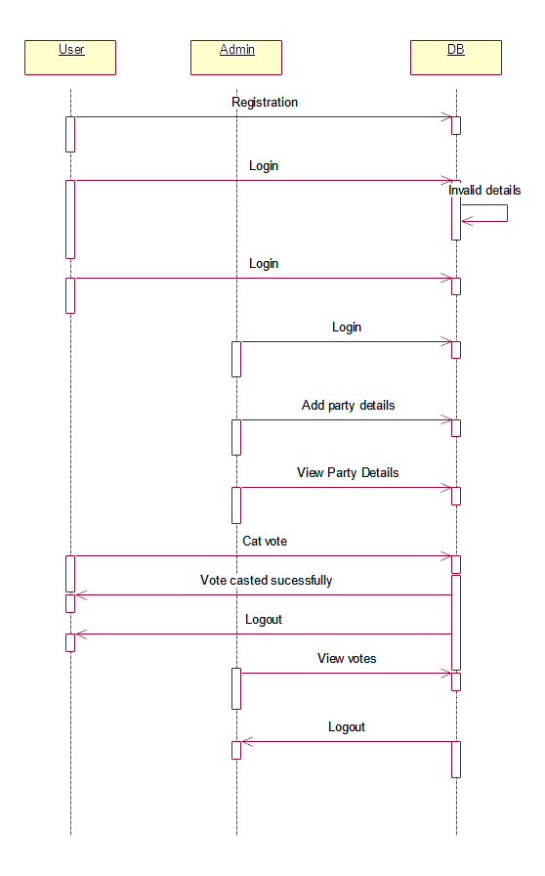

**Collaboration diagram:**

A collaboration diagram groups together the interactions between different objects. The interactions are listed as numbered interactions that help to trace the sequence of the interactions. The collaboration diagram helps to identify all the possible interactions that each object has with other objects.



**DATA FLOW DIAGRAM:**

1. The DFD is also called as bubble chart. It is a simple graphical formalism that can be used to represent a system in terms of input data to the system, various processing carried out on this data, and the output data is generated by this system.
2. The data flow diagram (DFD) is one of the most important modeling tools. It is used to model the system components. These components are the system process, the data used by the process, an external entity that interacts with the system and the information flows in the system.
3. DFD shows how the information moves through the system and how it is modified by a series of transformations. It is a graphical technique that depicts information flow and the transformations that are applied as data moves from input to output.
4. DFD is also known as bubble chart. A DFD may be used to represent a system at any level of abstraction. DFD may be partitioned into levels that represent increasing information flow and functional detail.

**User registration**

**VERIFY**

**NO PROCESS**

**Yes NO**

**Admin login**

**Add party details**

**View party details**

**User login**

**Cast vote**

**Vote casted successfully**

**Admin view votes**

**logout**

**End process**

**Fig.5.1.3 Dataflow diagram**

**3.3.2 ADMIN CASE DIAGRAM:**

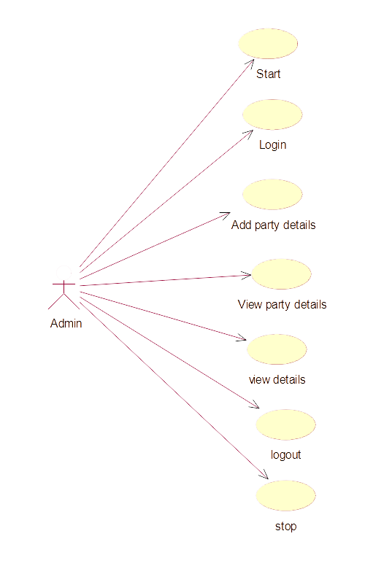

**3.3.3 USER CASE DIAGRAM:**

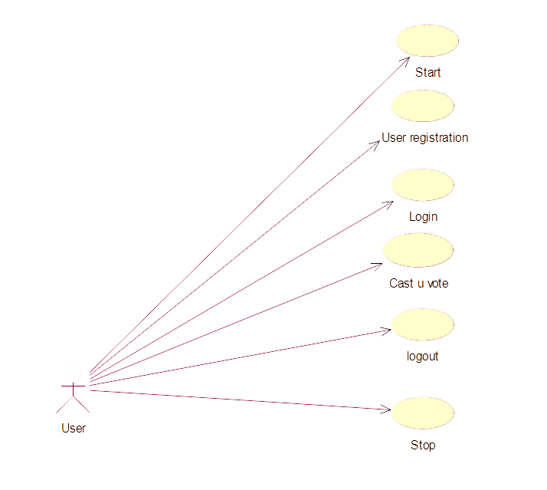

**Activity diagram:**

The process flows in the system are captured in the activity diagram. Similar to a state diagram, an activity diagram also consists of activities, actions, transitions, initial and final states, and guard conditions.

Admin login

Add party details

View party details

View details

Logout

User registration

User login

Cast u vote

Logout

**3.3.4 CLASS DIAGRAM:**

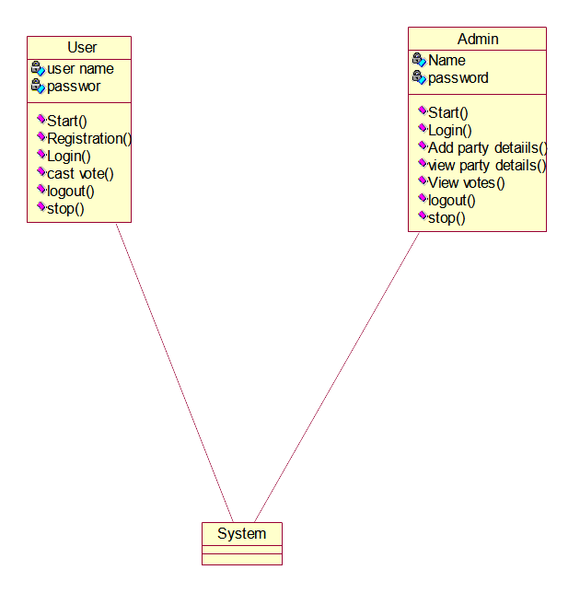

**3.4 SYSTEM ARCHITECTURE**

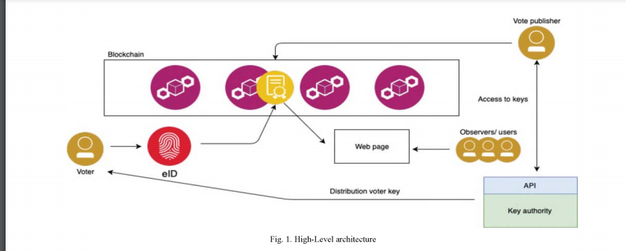

**IMPLEMENTATION:**

Admin: this user is responsible for adding new party and candidate information, seeing party information and voting numbers. Admin system login by using 'Admin' username and 'Admin' password.

User Module: This user must register with the app by using the name of their user as their ID and then upload a face photo via a camera. You can go to the log-in after registering which validated user ID and go to the cast vote module that runs following functionality after successful registration.

First user is connected and the picture captured in his PC webcam

With the OpenCV application, faces are detected and CNN application predicts the user identity, then the application displays all voting candidacies if user identification matches CNN predicted face. If you don't vote, you can vote to your wishes by clicking on the link next to the name of your party. When applying for votes, the voter and the candidate details will be collected and then the data will be crypted and stored in Blockchain. Below is the code of Blockchain's storage

**CHAPTER-4**

**IMPLEMENTATION**

**4.1 SYSTEM REQUIRMENTS:**

HARDWARE REQUIREMENTS

* SYSTEM : PC/COMPUTER WITH WEBCAM SUPPORT
* HARDDISK : 1 TB
* PROCESSOR : Intel(R) Core(TM) i3 i5 i7
* TYPE : 32-Bit,64-Bit Operating System
* RAM : 4-GB,8-GB,12-GB

SOFTWARE REQUIREMENTS

* OPERTAING SYSTEM : Windows
* Programming Language : Python
* API : Tensor Floe with keras API

**4.2SOFTWARE IMPLEMENTATION:**

**4.2.1 PYTHON INTRODUCTION:**

* The Python programming language is a common objective, dynamic, high-quality and interpreted. It enables Object-oriented application development programming approach. It is straightforward to learn and offers a large number of high-level data structures.
* Python is a strong and versatile language that is nevertheless easy to learn, making it attractive to the development of apps.
* The syntax of Python and its interpreted dynamic type are a good language for the construction of scripts and fast-moving applications. Python
* supports numerous patterns of programming, including object-oriented, imperative or procedural methods of programming.
* The objective of Python is not to work in particular areas like web programming. This is because it may be utilized for web, company, 3D cad etc. It is called multipurpose.
* We don't want to use data types to declare the variable because the variable is dynamically typed, so that we can write a=10.
* Python does develop and debug quickly because no build phase in python development and the edit-test-debug cycle has very quickly been added.

**4.2.2 THE STORY OF PYTHON:**

* In the late 1980s, Python was founded.
* Guido Van Rossum began implementing the Python at CWI in the Netherlands in December 1989.
* Van Rossum has released the code to alt. sources in February 1991 (labelled version 0.9.0).
* In 1994, additional features such as lambda, map, filter and reduce were published for Python 1.0.
* Python 2.0 adds new features such as: list understanding, waste collection system.
* Python 3.0 was released on 3 December 2008 (also known as "Py3K"). It has been intended to correct basic linguistic defects.
* ABC is supposed to be a Python language ancestor capable of handling exceptional problems and interacting with Amoeba's operating system.
* The following programming languages are influenced by Python:
* Language of ABC.
* Modula-3

**4.2.3 FEATURES OF PYTHON:**

Python offers many of the following functionalities-

**1)** Learning and using easily

The learning and use of Python is easy. It is a high-level programming language that supports developers.

**2)** Language Expressive

The more expressive python language means it is more readable and comprehensible.

**3)** Language of interpretation

Python is an interpreted language i.e. the translator runs the line of code at a time. This simplifies and therefore allows debugging for novices.

**4)** Language multi-platform

On several systems such as Windows, Linux, Unix, Macintosh, etc., Python can work equally. So, Python's a portable language, we might claim.

**5)** Open Source and Free

The Python language can be found at official web address free of charge.

You may also access the source code. It's free source, therefore.

**6)** Language oriented towards objects

Python enables object-oriented language and class and object ideas come into being.

**7)** Continuous.

It indicates that the code can be compiled in other languages such as C++ and used in our Python programmers.

**8)** Wide Standard Bibliotheque

Python has a wide library that offers a range of modules and functions for quick creation of applications.

**9)** Support for GUI Programming

Python allows the development of graphical user interfaces.

**10)**Integrated

The languages such as C, C++, JAVA, etc. can be simply incorporated.

**4.2.4 APPLICATIONS FOR PYTHON:**

For its general purposes, Python is known to apply in practically every software development domain. In any sector of development, Python as a whole can be employed.

We specify here areas of application in which python can be employed.

**1)** Applications web

For web apps, we can utilize Python. It offers libraries that handle protocols like HTML or XML, JSON, e-mail, request, beautiful Soup and Feed parser, etc. It also offers frameworks for web applications such as Django, Pyramid, Flask etc. Imports include: PythonWiki Engines, Pocoo, PythonBlogSoftware, etc.

**2)** Applications Desktop GUI

Python offers the module Tk GUI to construct a Python user interface. Other interesting wxWidgets, Kivy, pyqt tools that can be used on multiple platforms. The Kivy is well-known for multitouch apps.

**3)** Development of software

Python is useful in developing software. It operates as a language of support and can be used for control and management building, tests, etc.

**4)** Numerical and scientific

Python is popular and frequently used in the fields of science and numerics. SciPy, Pandas, IPythonetc are some useful libraries and packages. SciPy is an engineering, science and math group. set of packages.

**5)** Applications for business

For business applications such as ERP and e-commerce platforms, Python is employed. Tryton is an application platform of high standard.

**6)** Application Console Based

Python can be used to construct application-based consoles. I Python for instance.

**7)** applications based on audio or video

Python is great for doing many tasks and for developing multimedia apps. Some legitimate apps are: TimPlayer, cplay and so on.

**8)** Apartments in 3D CAD

CAD application creation Fandango is a true programmer that offers complete CAD functions.

**9)** Company applications

In the context of an enterprise or an organization, Python may be used to construct apps. Some apps in real time are: OpenErp, Tryton, Picalo, etc.

**10)** Picture applications

Multiple application for the image can be created using Python. Developed applications are: VPython, Gogh, imgSeek and so on.

**11)** Many of these applications can be developed with Python

How to set up Python (Environment Set-up)

The installation of python on different operating system are discussed in this part.

Python Why

* Python operates on various systems (Windows, Mac, Linux, Raspberry Pi, etc).
* Python has an English-like easy syntax.
* Python offers a syntax which allows developers to construct less-lines applications than some other languages.
* Python works on an interpreter system, thus code can be executed when written. Prototyping can therefore be quite fast.
* Python can be processed, handled by object, or functional methods.
* Well done to know
* Python 3, which we will be using in this course, is a most recent major version of Python. Python 2, however, is still very popular, albeit not maintained with security patches.
* Python is written into a text editor in this session. In an integrated development environment like Thonny, Pycharm, Netbeans or Eclipse, Python can be written which are particularly helpful in the management of big Python collections.
* Compared to other programming languages Python Syntax
* Python was created to be readable and has commonalities with mathematical influences with the English language.
* In contrast to other programming languages, Python is using a new command line, which typically employs semicolons or parentheses.
* Python uses whitespace to set the range for indentation, including range of loops, functions, and classes. Curly brackets are widely used to this end for other programming languages.

**4.3 PYTHON SETUP:**

To obtain Python's latest release please visit the website https://www.python.org/downloads/. We are installing Python 3.6.7 on our operating system on Windows in this process.



Fig.4.1 Python Setup

Fig 4.1Double click on the downloaded executable file; open the next window. Choose Customize and continue installation.

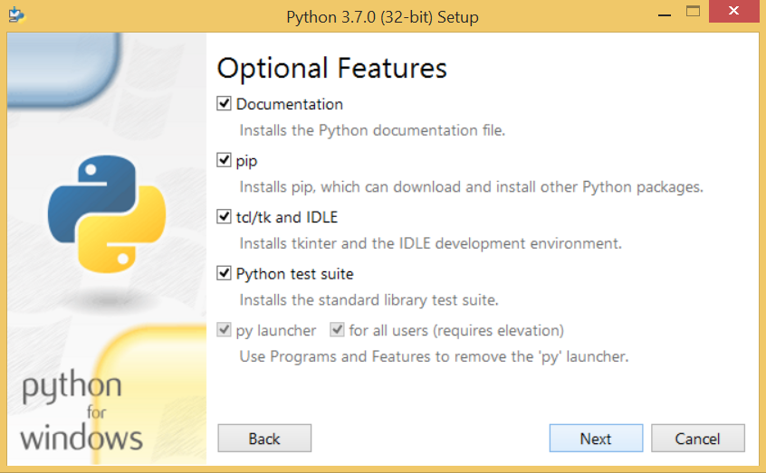

Fig.4.2 Python Optional Features

Fig 4.2The following window shows all the optional features. All the features need to be installed and are one checked by default; we need to click next to continue.

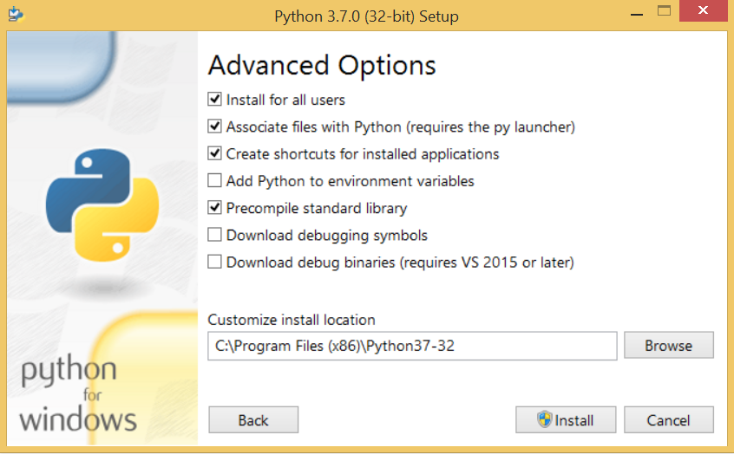

Fig.4.3 Python Advanced Options

Fig 4.3 The following window shows a list of advanced options. Check all the options which you want to install and click next. Here we must notice that the first check box (install for all users) must be checked.



Fig.4.4 Python Installation

Fig 4.4 Now we are ready to install python 3.6.6. Let’s install it

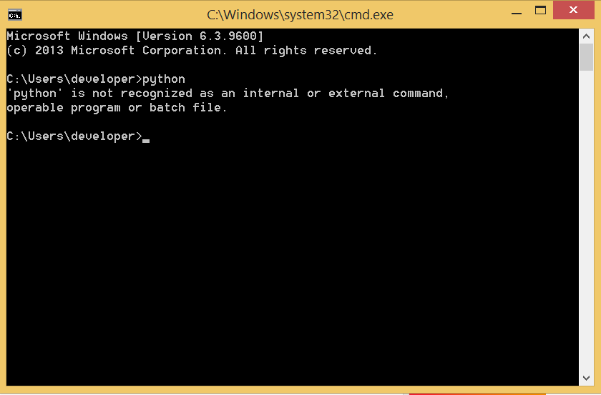

Fig.4.5 Command Prompt

Fig 4.5 Now, try to run python on the command prompt. Type the command python in case of python2 or python3 in case of puthon3.It will show an error as give in below image. It is because we haven't set the path

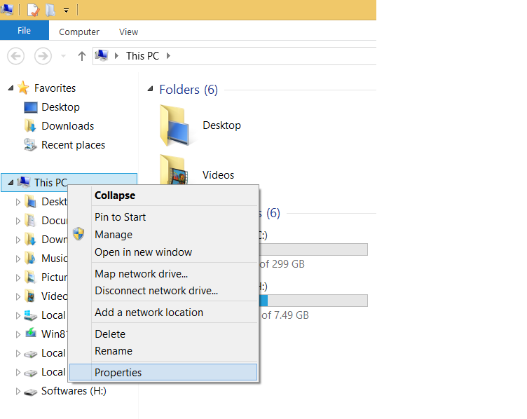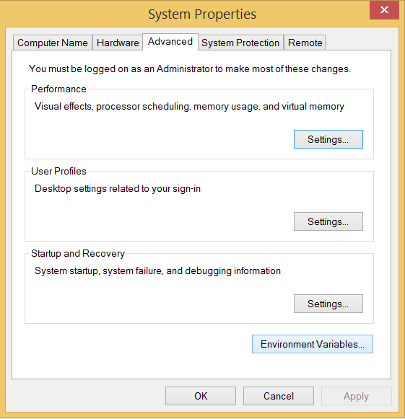

Fig 4.6 System Properties

Fig 4.6 To set the path of python, we need to right click on my computer and go to Properties>>>Advanced>>>>Environment Variables.

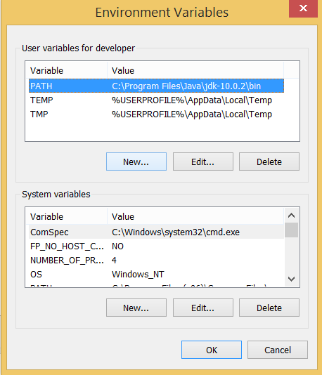

Fig 4.7 Environment Variables

Fig 4.7 Add the new path in the user variable section

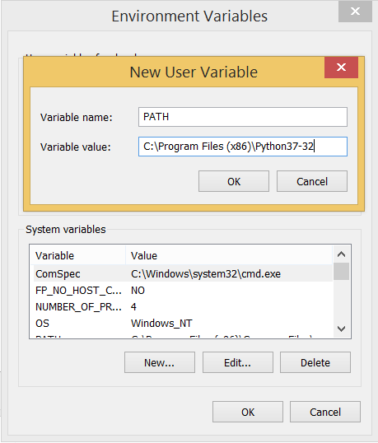

Fig 4.8 New User Variable

Fig 4.8 Now the path is set we are ready to run python on our local system.Restart CMD and type python again. It will open the python interpreter shell where we can execute the python statements.

**4.4 VIRTUAL ENVIRONMENTS AND PACKAGES:**

Python programmers frequently employ packages and modules not included in the standard library. The applications occasionally need a certain library version since the applications may require a fixed problem, or because an old version of the library interface could be used to write the application. This means that one Python installation may not fulfil each application's requirements. If application A needs version 1.0 of a specific module while version 2.0 is required for application B, then requirements conflict, which means one programmer cannot operate if version 1.0 or 2.0 is installed.

A virtual environment, an in-house directory tree, containing a Python-installation for a specific Python version plus a number of further packages, is the answer for the problem.

Various programmers can employ various virtual environments. Application A may have a virtual environment of its own with version 1.0 installed to solve a previous example of the conflicting requirements while Application B has a virtual environment of version 2.0. If Application B needs to upgrade a library to version 3.0, this will not affect the environment of Application.

**VIRTUAL ENVIRONMENTS CREATION**

Venv is the module for the creation and management of virtual environments. The most recent Python release you have will normally be installed by venv. You can choose a certain Python version by running Python3 or which one you want if you have several versions of Python on your machine.

Decide on a directory to place the virtual environment and use the venv module in the directory path as a script for creating:

Tutorial-inv python3 -m

If it doesn't exist, it creates the tutoriel-env directory and it also creates directories holding a copy of the Python interpreter, the standard library and different files that support it.

A popular virtual environment directory location is.venv. This name maintains the directory in your shell and so excludes you from the manner it is given a name to explain why this directory exists. It also prevents conflict with files that some tooling offers for environment variable definition. NV.

Once you've created a virtual environment, you may activate it.

On Windows, run:

O tutorial-env\Scripts activate bat

On Unix or MacOS, run:

source tutorial-env/bin/activate

(This is a Bash shell script produced. If you are using csh or fish shells, activate.csh and activate.fish are alternate, instead.)Enabling the virtual environment will update the shell prompt to show the virtual environment you use and change the environment so that executing python will provide you with this particular Python version and install . For instance:

S source/envs/tutorial-env/bin/activate

(tutorial-env) S python

Python 3.5.1 (default, May 6 2016, 10:59:36)

...

>>> import sys

>>>sys.path

[", "/usr/local/lib/python35.zip

~/envs/tutorial-env/lib/python3.5/site-packages']

>>>

**MANAGING PACKAGES WITH PIP**

Using an application called pip, you may install, upgrade and uninstall programmers. The Python Package Index, <https://pypi.org>, installs packages by default. By switching to your web browser, you can browse the Python package index, or utilize the limited search function for Pip.

(tutorial-env) S pip search astronomy

Skyfield - Elegant astronomy for Python

Garyn - Galactic astronomy and gravitational dynamics.

Novas - The United States Naval Observatory NOVAS astronomy library

Astroobs - Provides astronomy ephemeris to plan telescope observations

PyAstronomy – A collection of astronomy related tools for Python

pip has a number of subcommands; "search", "install", "uninstall", "freeze", etc. (Consult the

Installing Python Modules guide for complete documentation for pip.)

You can install the latest version of a package by specifying a package's name:

(tutorial-env) S pip install novas

Collecting novas

Downloading novas-3.1.1.3.tar.gz (136kB).

Installing collected packages: novas

Running setup.py install for novas

Successfully installed novas-3.1.1.3

You can also install a specific version of a package by giving the package name followed by = and the version number:

(tutorial-eny) $ pip install requests=2.6.0

Collecting requests=2.6.0

Using cached requests-2.6.0-pylpy3-none-any.whl

Installing collected packages: requests

Successfully installed requests-2.6.0

If you re-run this command, pip will notice that the requested version is already installed and do nothing. You can supply a different version number to get that version, or you can run pip install —upgrade to upgrade the package to the latest version:

(tutorial-en) $ pip install —upgrade requests

Collecting requests

Installing collected packages: requests

Found existing installation: requests 2.6.0

Uninstalling requests-16M:

Successfully uninstalled requests-2.6.0

Successfully installed requests-2.7.0

PAR uninstall followed by one or more package names will remove the packages from the virtual environment.

RIR show will display information about a particular package:

(tutorial-env) $ pip show requests

Metadata-Version: 2.0

Name: requests

Version: 2.7.0

Summary: Python HTTP for Humans.

Home-page: http://python-requests.org

Author: Kenneth Reitz

Author-email: me@kennethreitz.com

License: Apache 2M

Location: /Users/aktchlinenvs/tutorial-enviliblpython3.4/site-packages Requires:

p.m) list will display all of the packages installed in the virtual environment:

(tutorial-en!) $ pip list

novas (3.1.1.3)

nus (1.92)

pip (7M3)

requests (2.7M)

setyvt-upmals (16.0)

pip freeze will produce a similar list of the installed packages, but the output uses the format that pip install expects. A common convention is to put this list in a requirements.txt file:

(tutorial-en!) $ pip freeze > requirements.txt

(tutorial-envy $ cat requirements.txt

novas=3.1.13

nur-1.9.2

requests=2.7.0

The requirements.txt can then be committed to version control and shipped as part of an application. Users can then install all the necessary packages with install -r:

(pktoial:eny) $ pip install -r requirements.txt

Collecting novas=3.1.13 (from -r requirements.txt (line 1))

Collecting nus--1.9.2 (from -r requirements.txt (line 2))

Collecting requests=2.7.0 (from -r requirements.txt (line 3))

Installing collected packages: novas, nusy, requests Running setup.py install for novas

Successfully installed novas-3.1.1.3 numpy-1.92 requests-23M

Pip has a lot more possibilities. For detailed pip documentation, please consult the Python Modules Installation Guide. Please see the Distributing Python Modules instructions when you write a package and want to make it available on the Python Package index.

**CHAPTER-5**

**RESULT AND ANALYSIS**

**5.1 BLOCKCHAIN TECHNOLOGY**

The blockchain component represents the entire data storage architecture and operates voting. The blockchain may be developed using public blockchain technologies, such as Ethereum or a private blockchain, for instance Hyperledger. The advantages of the public blockchain are that it provides all transaction and block information to all users and this is why it has better trust than the private blockchain. This trust is in the context of a regular user who is not state-of-the-art and wants to view all information. The private blockchain can provide the same level of trust, but it has to be shown by data by an organization. It does not limit what blockchain should be used in the proposed architecture. Both blockchain types can provide the same amount of trust. The platform chosen is the organizational decision to create elections.

B. Units Voting security is based on blockchain and a smart contract is carried out that belongs to the Blockchain processing system. After a configuration, the intelligent contract is released to the blockchain network. Contains times, candidates or other properties in the configuration. The candidate must not be a person; he symbolizes anything that is the purpose of the electoral process. The published intelligent agreement cannot be edited or altered to make the vote transparent. A list of users who are qualified to vote can be found on this smart contract. A key distribution must be followed by the access list that is made by the major authority.

Admin: this user is responsible for adding new party and candidate information, seeing party information and voting numbers. Admin system login by using 'Admin' username and 'Admin' password.

User Module: This user must register with the app by using the name of their user as their ID and then upload a face photo via a camera. You can go to the log-in after registering which validated user ID and go to the cast vote module that runs following functionality after successful registration.

First user is connected and the picture captured in his PC webcam

With the OpenCV application, faces are detected and CNN application predicts the user identity, then the application displays all voting candidacies if user identification matches CNN predicted face. If you don't vote, you can vote to your wishes by clicking on the link next to the name of your party. When applying for votes, the voter and the candidate details will be collected and then the data will be crypted and stored in Blockchain. Below is the code of Blockchain's storage

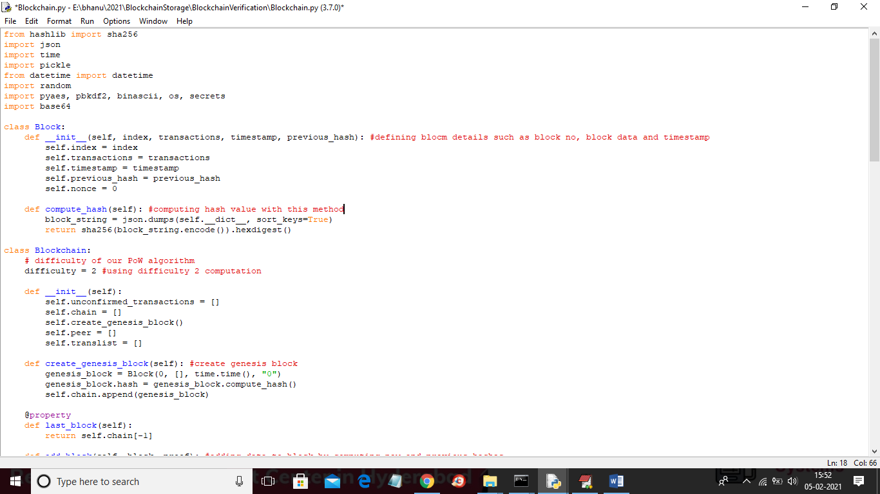

Fig 5.1 Blockchain Storage Code

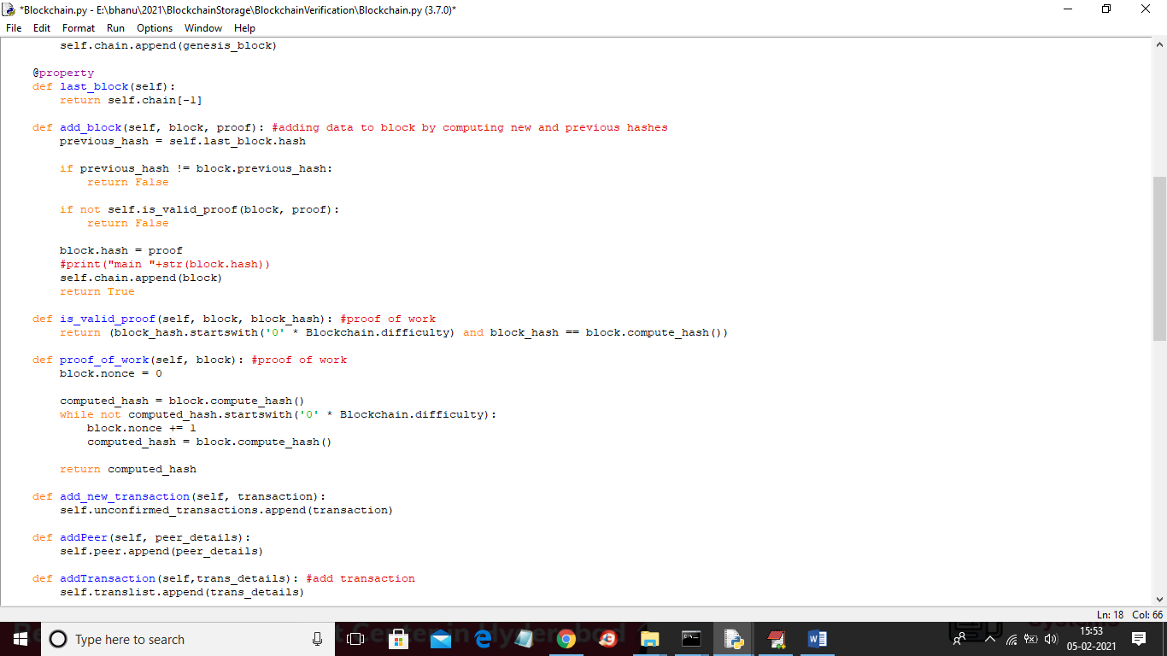

Fig 5.2 Blockchain Storage Code



Fig 5.3 Blockchain Storage Code

**5.2 RESULTS:**

**Fig: 5.4 Website Page of E-Voting**

Fig:5.4 In above screen click on 'Admin Login' link to get the screen. It consists of Admin Login, User Login, Register new. When Admin login then with filling of all details the person can login. If any person is new then he needs to register in the portal. User can login to cast his vote.



**Fig:5.5 Admin Login Screen**

Fig:5.5 When Admin Login into portal Screen then it displays as shown in above figure. It consists of Username and password with this detail’s admin person can login into portal. Then with the given details the admin gets the access to login in to portal.

**Fig:5.6 Welcome Admin**

Fig:5.6 It displays the Add party Details link to add party details. As we have many parties in our country so we can add parties as we required. So that the voters can cast their vote to their representative.



**Fig:5.7 Add Party Candidate**

Fig:5.7 In above screen it displays screen about adding party and candidate details and the upload image and click on 'Open button then click on 'Add party' button to add party details. The add party screen consists pf Candidate Name, Party Name, Area Name, Profile Image. Then after filling in to the details click on the Add party button then it is going to add the party.

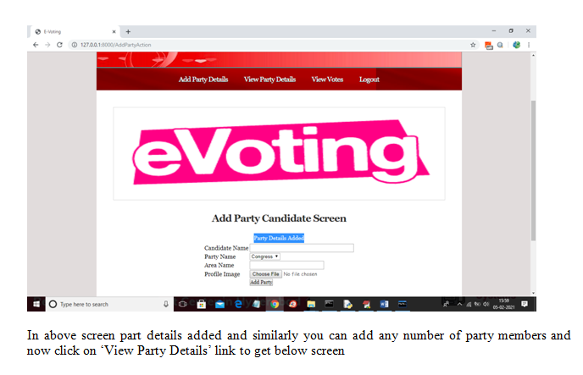**Fig:5.8 Party Details Added Screen**

Fig:5.8 In the above screen part details added and similarly you can add any number of party members and now click on "View Party Details" link to get below screen.

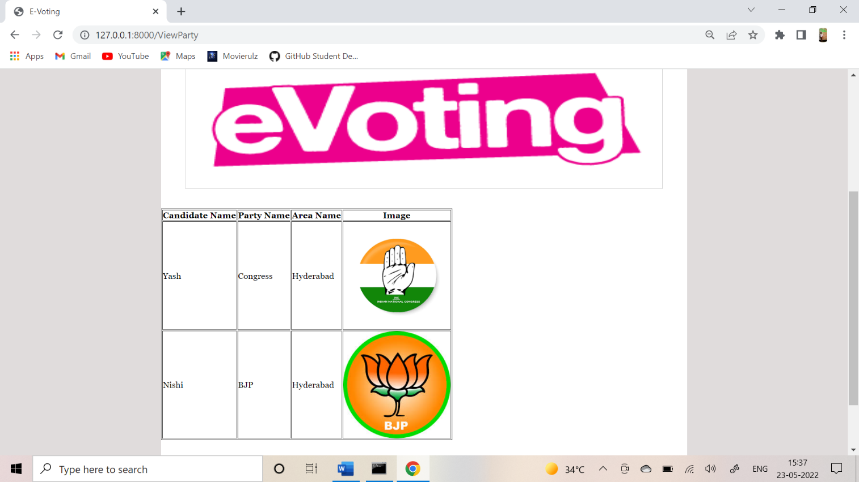

**Fig:5.9 View Party Details**

Fig:5.9 It displays the screen after adding party details. Now click on Logout link to logout as admin role. After clicking on the Logout then admin role is logged out from the portal.Then we can add new user in to the portal.

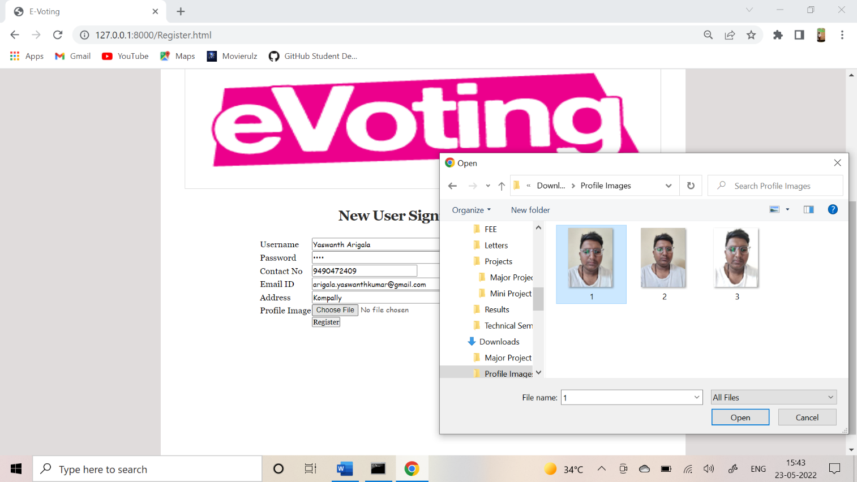

**Fig:5.10 New User Signup Screen**

Fig:5.10 The screen displays New User Sign it consists of User Name, Password, Contact Number, Email I'd, Address Profile Image. After filling all the details of the new user then click on the Register then the person is going to get new registration.

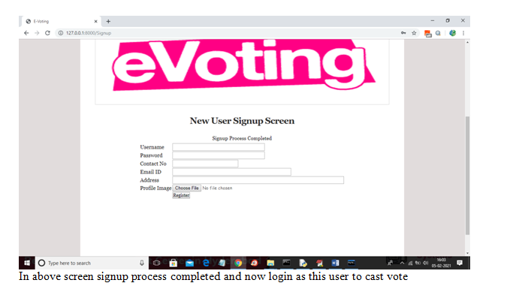

**Fig:5.11 Signup Process Completed**

Fig:5.11 After filling all the details of new user then the screen is opened as New User Signup Screen then the person can cast their vote in the portal.

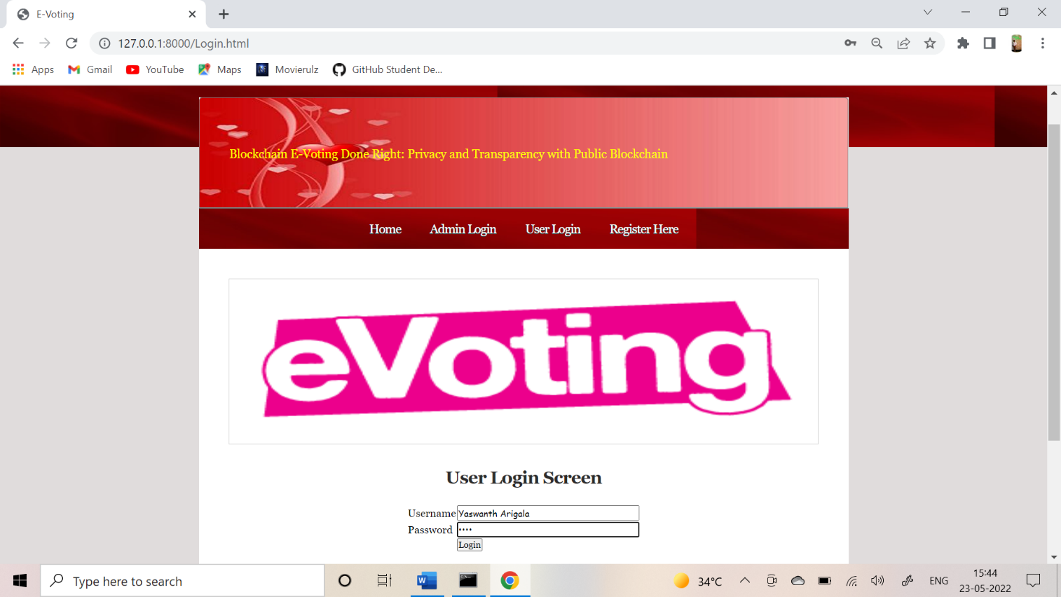

**Fig:5.12 User Login Screen**

Fig:5.12 The screen displays the User Login Screen which contains Username and password after filling the details then click on the Login button.



**Fig:5.13 Welcome User Screen**

Fig:5.13 After filling the details of the user then it is going to display as 'Cast your Vote’. It displays the cast your vote and logout buttons.



**Fig:5.14 Verification Page**

Fig:5.14 With the help of webcam we need to take snapshot if it matches with the user details then it is going to get as Validate User.

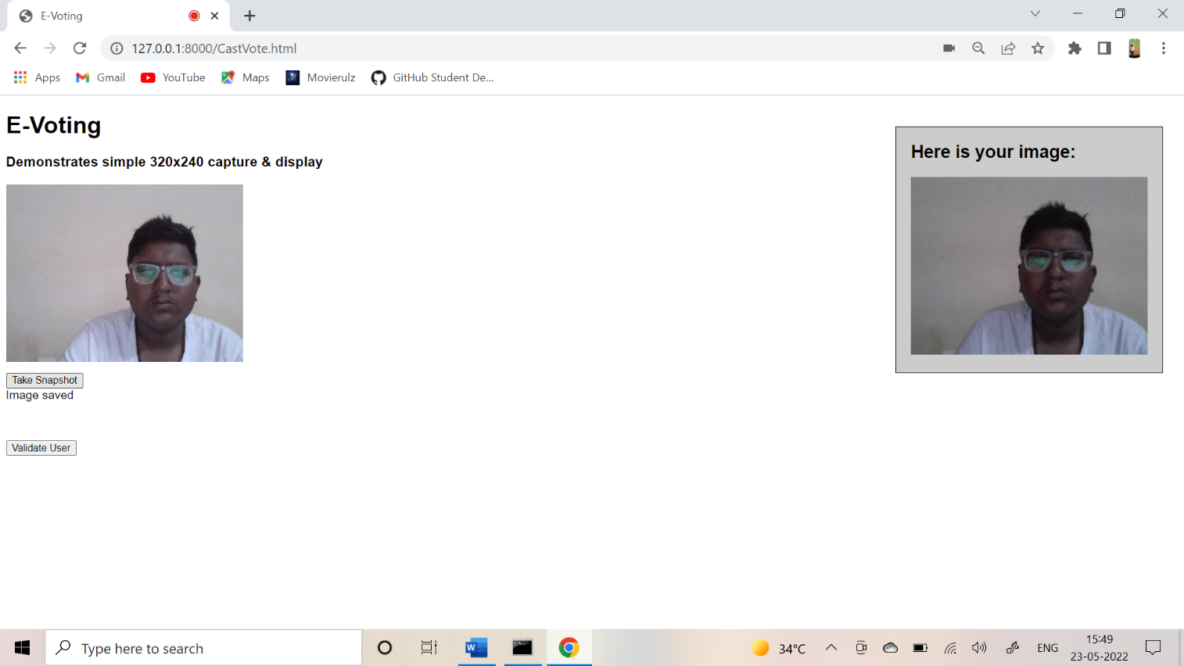**Fig:5.15 Validate User Screen**

Fig:5.15 It is going to display the image which is already stored one and the snapshot which is taken now. Then click on Validate User then it displays whether the information is matched or not.

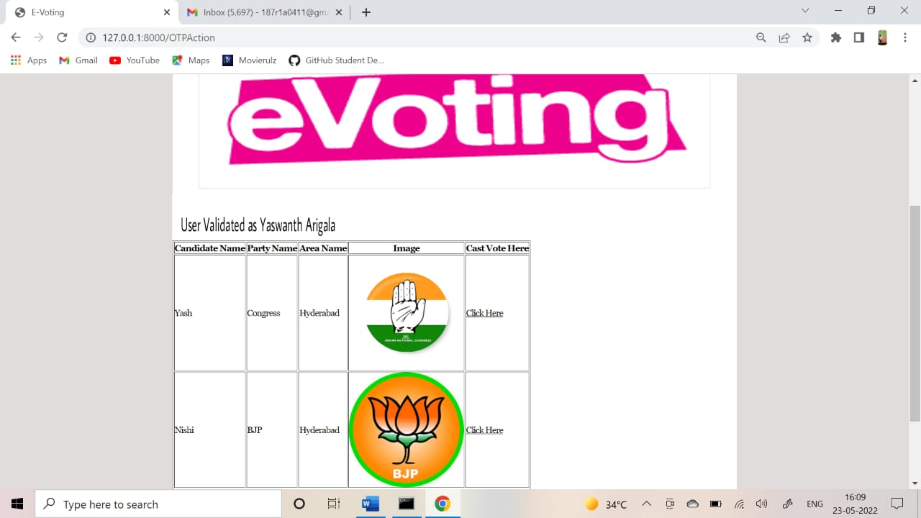

**Fig:5.16 User Validated Screen**

Fig:5.16 In above Screen we can see users is identified as 'User Name' and then it displays list of candidates and now user can click on 'Click Here' option to cast his vote and to get Below Screen.

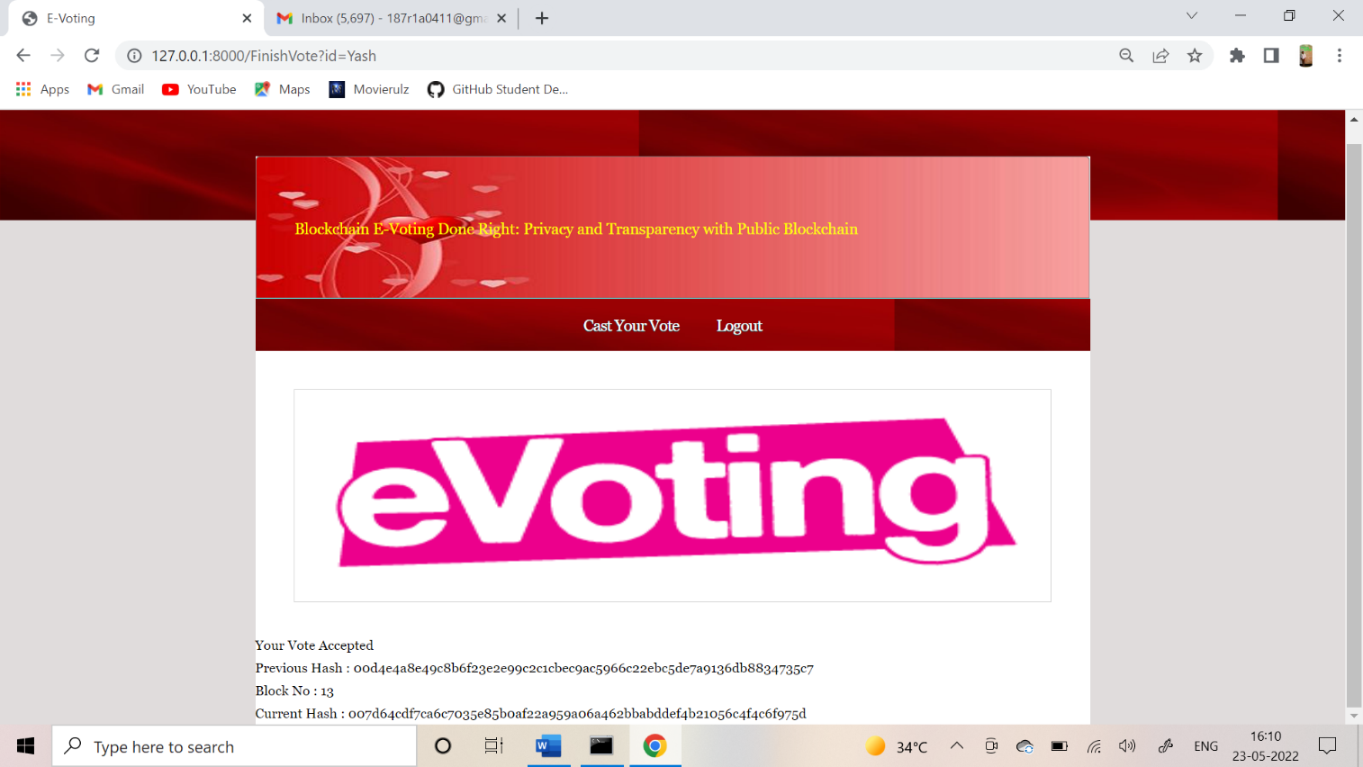**Fig 5.17 Vote Accepted Screen**

Fig:5.17 The above Screen displays aa this is the first vote so block will be added to Block Chain with block No as 1 and we can see Block Chain created a chain of blocks with previous and current hash code validation.



**Fig:5.18 Validate User Screen**

Fig:5.18 Here user is trying to login again then the process displays in this way ,takes snapshot. Click on Cast your vote.

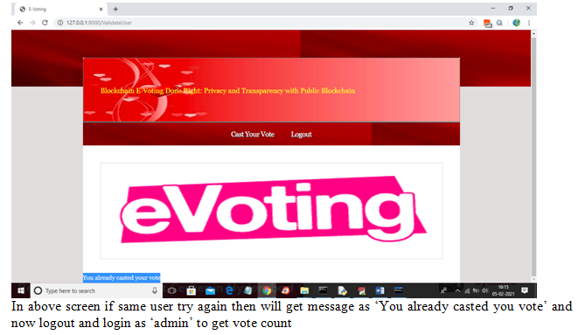

**Fig:5.19 Casted Your Vote**

Fig:5.19 The screen displays user is trying to cast his vote again. At bottom it is displayed as You already casted your vote.

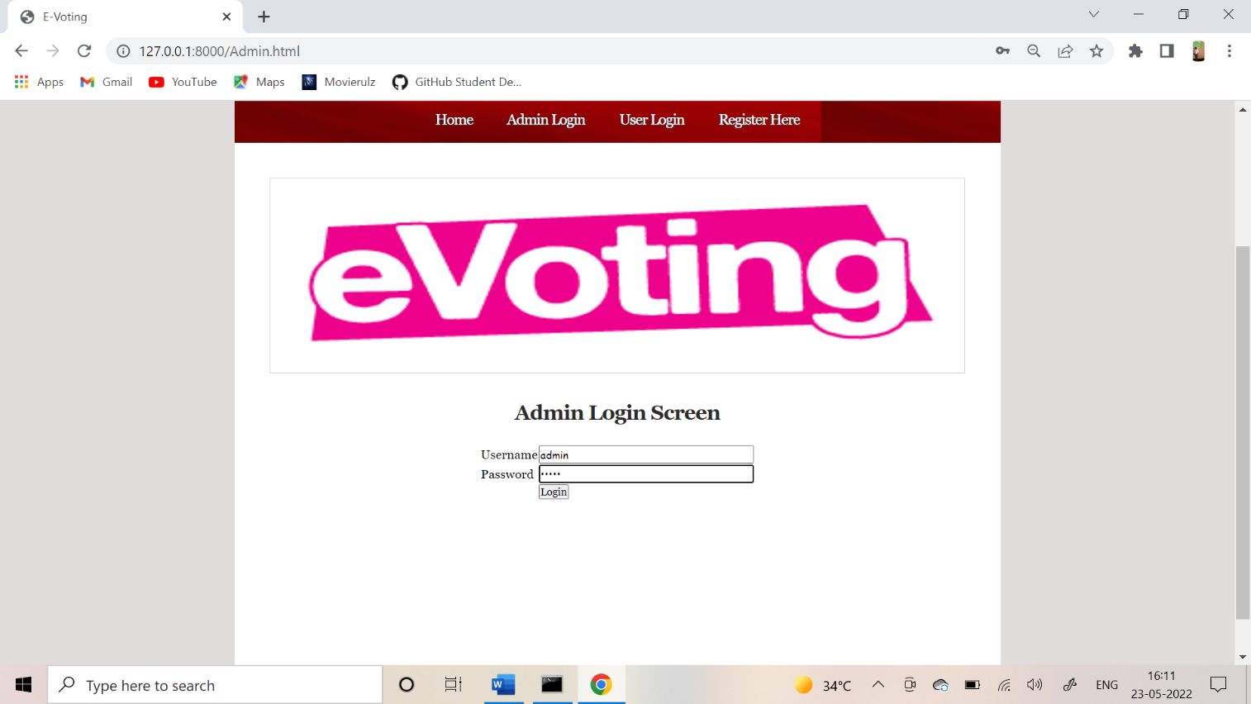**Fig:5.20 Admin Login Screen**

Fig:5.20 The screen displays Admin Login Screen with the User Name and password the admin can login into portal.



**Fig:5.21 Welcome Admin Screen**

Fig:5.21 The screen displays Admin can click on View Vote link to get how many votes they have got.

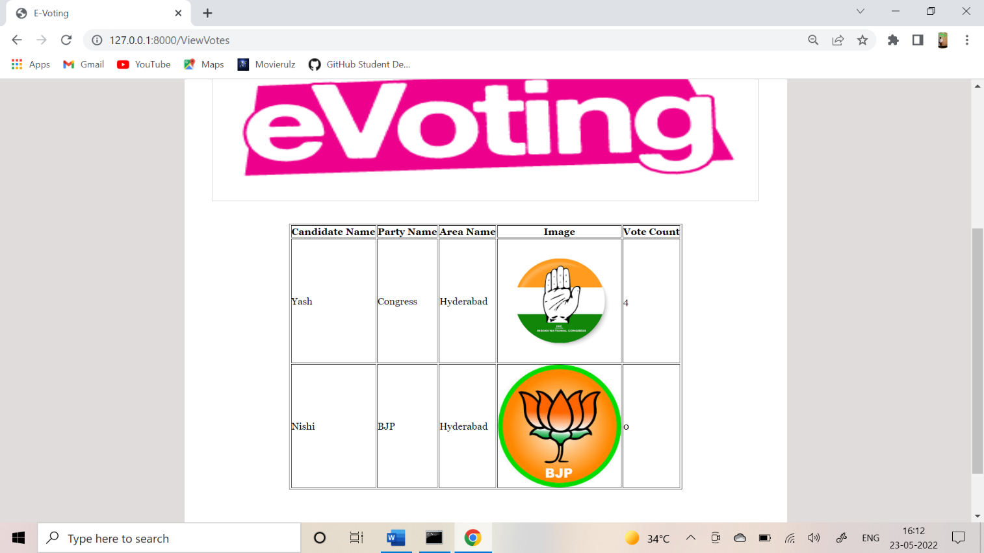**Fig:5.22 Number of Votes Screen**

Fig:5.22 The screen displays the admin can view all vote counts how many votes they got for each candidate. The screen displays Candidate Name, Party Name, Area Name, Image, Vote Count.

**Fig:5.23 Admin View Votes Screen**

Fig:5.23 In above screen admin can view all vote counts. As per your request admin can view and count votes between 9 AM to 6 PM and same will applied for voter.

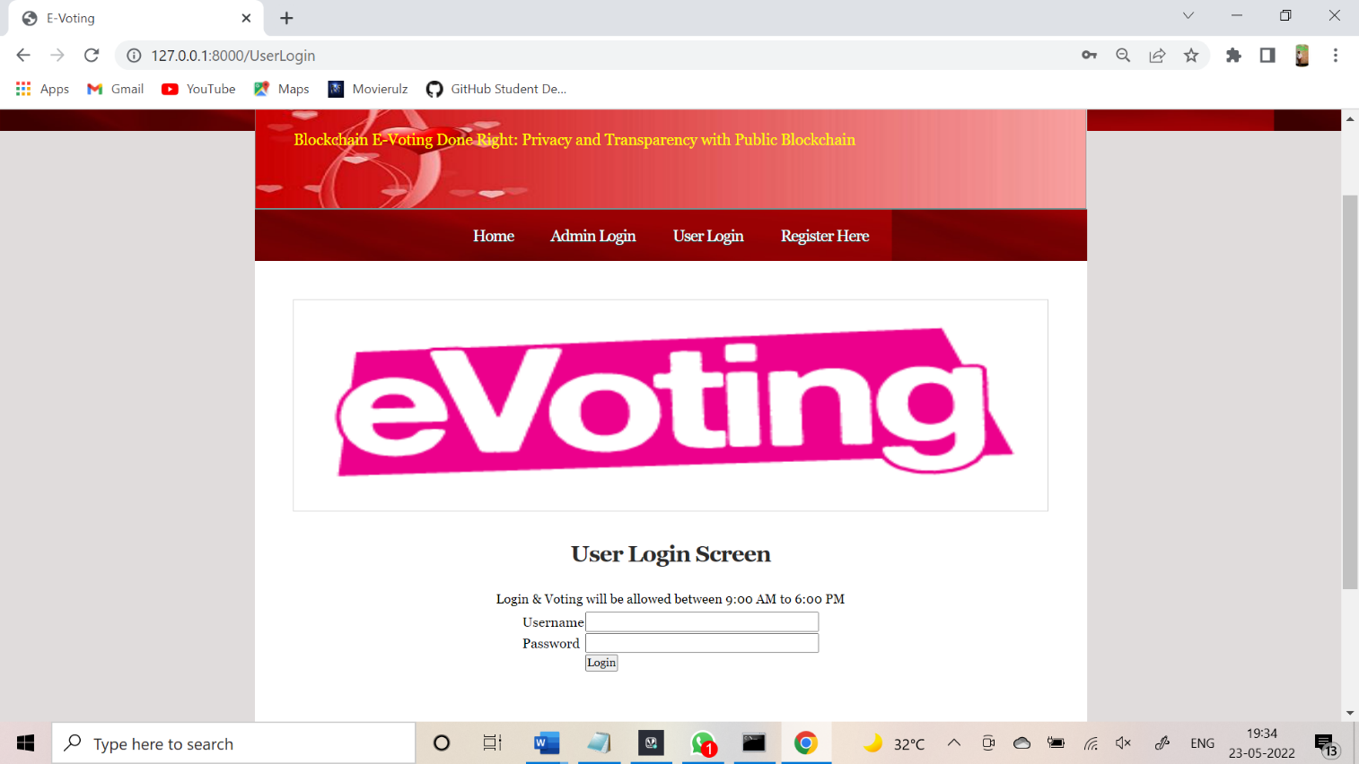

**Fig:5.24 User Login Screen**

Fig:5.24 In above Screen application displaying message for the users as Login and Voting allowed between 9 to 6PM.Once after validate user then application ask for OTP**.**

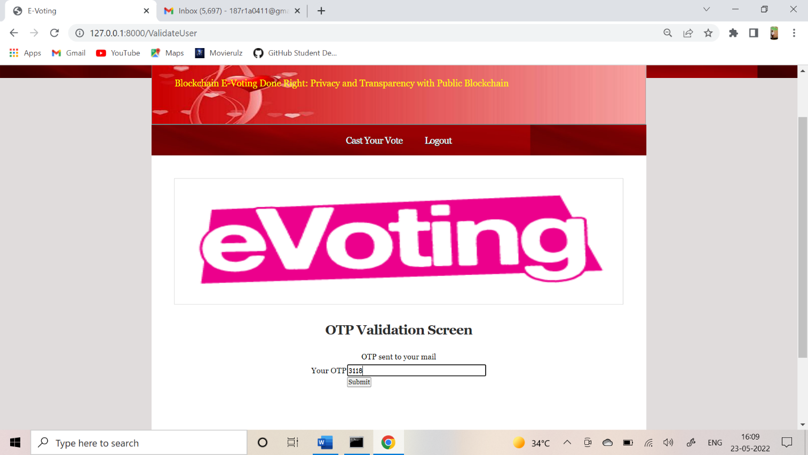

**Fig:5.25 OTP Validation Screen**

Fig:5.25 The screen displays the OTP VALIDATION SCREEN. It consists of OTP which is send to mail Id. Then click on submit button.

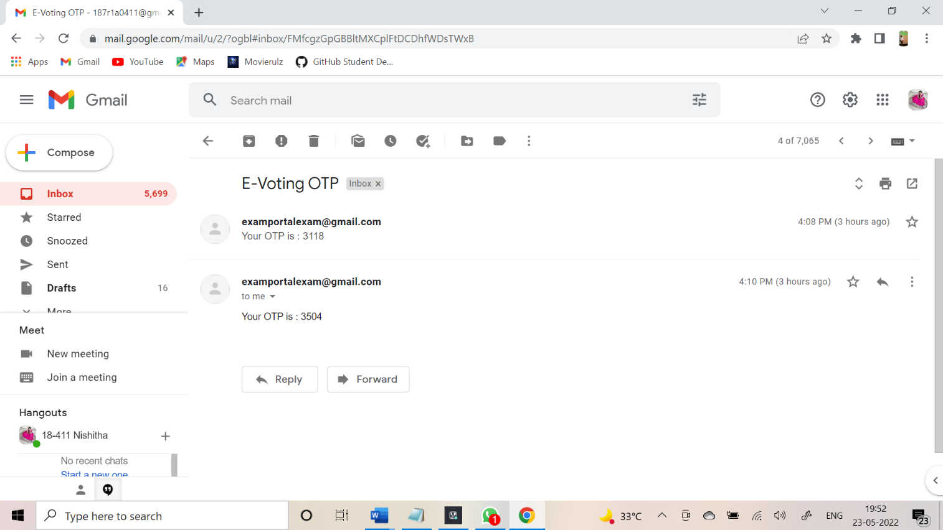**Fig:5.26 Mail OTP of E-Voting**

Fig:5.26 The screen displays the OTP which is send to mail.

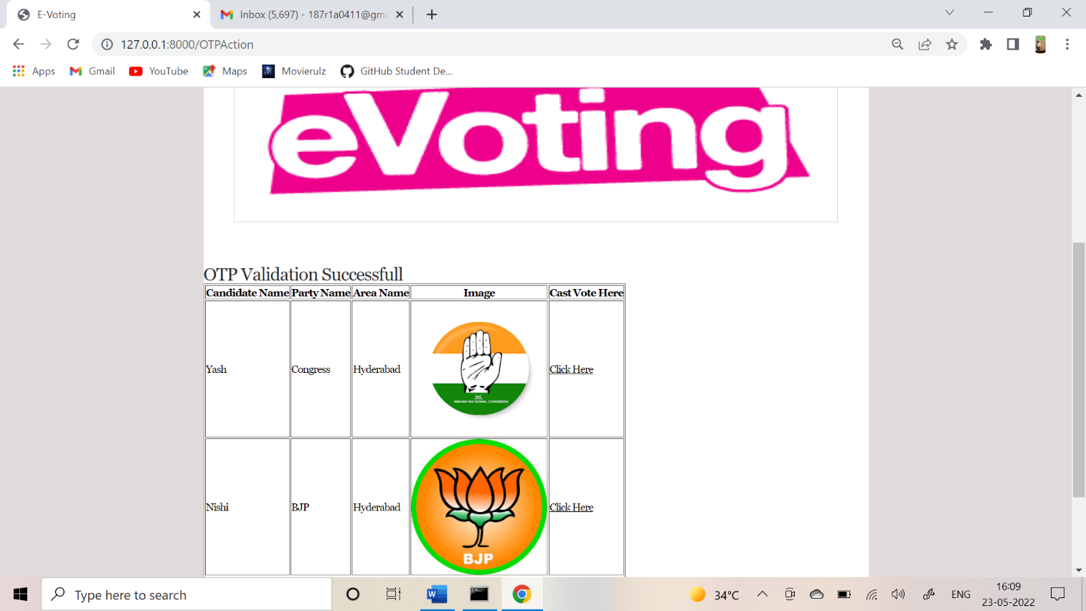

**Fig:5.27 OTP Validation Successful Screen**

Fig:5.27 OTP VALIDATION Successful screen then user can cast vote here.

**5.3 E-VOTING ADVANTAGES:**

* Accurate results and speed in vote count
* Low cost of setup because just internet connection cost is required to vote across all the available e-voting platforms
* Enhanced security as voting take place over secure communication channels
* Accessibility from any corner of the world just by having an internet connection
* Fraud prevention due to less human intervention therefore avoiding the fraud that could possibly take place at the polling stations
* Reduced influence by family members or peers as voters can change their opinion until end of the voting day several times as only the last vote will be considered.

**5.4 E-VOTING DISADVANTAGES:**

* In many developing countries internet access is not available to everyone, example: In rural areas low wage workers could not afford internet also many people don’t know how to use and access the web
* E-voting machines use software to register the vote and it is built by a company, general public don’t know how a software works that might lead to fraudulent results being generated, vendors could also be bribed and in return they could tweak the software to work in their favours.
* In the internet voting voter has to login by providing their personal and ID details, which will result in “Voter Anonymity” issue.
* There are situations when machine don’t produce accurate results due to some errors, malfunctions, along with the possibility of hacking.

**5.5 SECURITY REQUIREMENTS FOR VOTING SYSTEM:**

Suitable electronic voting systems should meet the following electronic voting requirements. Figure 5 shows the main security requirements for electronic voting systems.

1. Anonymity

Throughout the polling process, the voting turnout must be secured from externalinterpretation. Any correlation between registered votes and voter identities inside the electoral structure shall be unknown

2. Auditability and Accuracy

Accuracy, also called correctness, demands that the declared results correspond precisely to the election results. It means that nobody can change the voting of other citizens, that the final tally includes all legitimate votes, and that there is no definitive tally of invalid ballots.

3. Democracy/Singularity

A “democratic” system is defined if only eligible voters can vote, and only a single vote can be cast for each registered voter. Another function is that no one else should be able to duplicate the vote.

4. Vote Privacy

After the vote is cast, no one should be in a position to attach the identity of a voter with its vote. Computer secrecy is a fragile type of confidentiality, which means that the voting relationship remains hidden for an extended period as long as the current rate continues to change with computer power and new techniques.

5. Robustness and Integrity

This condition means that a reasonably large group of electors or representatives cannot disrupt the election. It ensures that registered voters will abstain without problems or encourage others to cast their legitimate votes for themselves. The corruption of citizens and officials is prohibited from denying an election result by arguing that some other member has not performed their portion correctly.

6. Lack of Evidence

While anonymous privacy ensures electoral fraud safeguards, no method can be assured that votes are placed under bribery or election rigging in any way. This question has its root from the start.

7. Transparency and Fairness

It means that before the count is released, no one can find out the details. It avoids acts such as manipulating late voters’ decisions by issuing a prediction or offering a significant yet unfair benefit to certain persons or groups as to be the first to know.

8. Availability and Mobility

During the voting period, voting systems should always be available. Voting systems should not limit the place of the vote.

9. Verifiable Participation/Authenticity

The criterion also referred to as desirability makes it possible to assess whether or not a single voter engaged in the election. This condition must be fulfilled where voting by voters becomes compulsory under the constitution (as is the case in some countries such as Australia, Germany, Greece) or in a social context, where abstention is deemed to be a disrespectful gesture (such as the small and medium-sized elections for a delegated corporate board).

10. Accessibility and Reassurance

To ensure that everyone who wants to vote has the opportunity to avail the correct polling station and that polling station must be open and accessible for the voter. Only qualified voters should be allowed to vote, and all ballots must be accurately tallied to guarantee that elections are genuine.

11. Recoverability and Identification

Voting systems can track and restore voting information to prevent errors, delays, and attacks.

12. Voters Verifiability

Verifiability means that processes exist for election auditing to ensure that it is done correctly. Three separate segments are possible for this purpose: (a) uniform verification or public verification that implies that anybody such as voters, governments, and external auditors can test the election after the declaration of the tally; (b) transparent verifiability against a poll, which is a weaker prerequisite for each voter to verify whether their vote has been taken into account properly.

TESTCASES:

|  |  |  |  |
| --- | --- | --- | --- |
| **S.NO** | **INPUT** | **If available** | **If not available** |
| 1 | User signup | User get registered into the application | There is no process |
| 2 | User signin | User get login into the application | There is no process |
| 3 | Admin login | Admin login into the application | There is no process |
| 4 | Add party details | Party details added | There is no process |
| 5 | View party details | Party details viewed | There is no process |
| 6 | Cast vote | User cast his vote | There is no process |
| 7 | View votes | User can view votes | There is no process |

**CHAPTER-6**

**CONCLUSION AND FUTURE SCOPE**

**6.1 CONCLUSION:**

Many issues with electronic voting can be solved using block chain technology, which makes electronic voting more cost-effective, pleasant, and safe than any other network. Over time, research has highlighted specific problems, such as the need for further work on block chain-based electronic voting and that block chain-based electronic voting schemes have significant technical challenges.

* Block Chain technology is a Scalability and Processing Overheads.
* It has great potential to decrease organizational costs and increase voter turnout.
* It eliminates the need to print ballot papers or open polling stations.
* Voters can vote from wherever there is an Internet connection.

This system has a double verification for more secure system. It has already data stored in it we may use that stored data or we can add extra another data also for the citizen identification to cast their vote. Through GSM, we can get a confirmation message about to which candidate the vote got registered to this way the elector can verify that the voter is pitched to his favourite candidate. It is very useful to physical handicapped people, people who are living in other places and no need to stand in queues to give their vote.

**6.2 FUTURE SCOPE:**

Voting is a constitutional right that we are privileged to have. We take it for granted, but the constitution has given us the right to elect who we want, and the right to make the change.

Another thing to be noted is that there may be many people who generally tend to think that a single vote doesn’t matter. But we often forget that every single vote can bring about a big change. In some cases, it is seen that a single vote can make a big difference between a capable and strong leader and a weak one. So, it is stressful to vote every time. Facial recognition is expected to become even more prominent over the next few years because of the advantages it offers over traditional surveillance techniques like biometrics. The technology can achieve highly accurate matches at long range, match multiple visitors simultaneously in high-traffic areas, provide real-time matching against databases, and maintain high accuracy despite hats, hoodies, glasses, and so on.Further research in the field can look into the following issues:

* We can add any other devices for better performance.
* The system can be improved by using other technologies also.
* Overcoming the problems of biometric voting system.
* We can develop through retina scan and iris scan technology.
* We know today voice assistant is playing a vital role so we can develop through voice also.

**REFERNCES**

1. BalaMurali, Potru Sarada Sravanthi, B. Rupa.” Smart and Secure Voting Machine using Biometrics”,2020 Proceedings of the Fourth International Conference on Inventive Systems and Control (ICISC), September 2020.
2. K.C Arun1, Shahbaz Ahmad2, Saba Noor3, Iqra Mumtaz4and Mubashir Ali5.” Based Secure Electronic Voting System with IoT and PubNub for Universities”.4th Global Conference on Computing & Media Technology,July 2020.
3. Mr. Santosh Kuma, Dr.NitikaSinghi, Abhijit Patankar.” A Survey on Smart Electronic Voting System through Block-Chain Technology”,2020 Journal of Emerging technologies and Innovative Research(JETIR), April 2020.
4. MD Shadab Hussain, Dr Mohammad Sarfraz, Salim Rukhsar. "Epileptic Seizure Detection Using Temporal Based Measures in EEG Signal", 2018 3rd International Conference on Communication and Electronics Systems (ICCES), 2018.
5. Nir Kshetri and Jeffrey Voas.” Block Chain-Enabled E-Voting.”2018 The Institute of Electrical and Electronics Engineers (IEEE),2018.
6. MichałPawlaka, AnetaPoniszewska-Maranda ´ a, Natalia Kryvinskab,c.” Towards the intelligent agents for block chain e-voting system.” 2018 The 9th International Conference on Emerging Ubiquitous Systems and Pervasive Networks (EUSPN ),2018.
7. M. Pawlak, J. Guziur and A. Poniszewska-Maranda,”Voting process with blockchain technology: Auditable Blockchain Voting System”,FatosXhafa, Leonard Barolli, MichaÅGreguÅ (Eds.): Advances in Intelligent Networking and Collaborative Systems, LNDECT 23, ISBN978-3-319- 98556-5, Chapter 21, Publisher: Springer-Verlag Heidelberg, 2018.
8. S. Mello-Stark and E. A. Lamagna,”The Need for Audit-Capable E-Voting Systems”, Proc. of 31st International Conference on AdvancedInformation Networking and Applications Workshops (WAINA), Taipei, Taiwan, 2017.
9. X. Xu, I. Weber, M. Staples, L. Zhu, J. Bosch, L. Bass, C. Pautasso and P. Rimba, ”A Taxonomy of Blockchain-Based Systems for Architecture Design”, Proc. of IEEE International Conference on Software Architecture (ICSA), Gothenburg, Sweden, 2017.
10. J.Deepika, S.Kalaiselvi ,S.Mahalakshmi, S.AgnesShifani “Smart Electronic Voting System Based On Biometric Identification-Survey”. Third International Conference on Science Technology Engineering & Management (ICONSTEM), 2017.
11. V. Kiruthika Priya, V. Vimaladevi, B. Pandimeenal, T. Dhivya, “Arduino based Smart Electronic Voting Machine”, International Conference on Trends in Electronics and Informatics, ICEI 2017,
12. Dr. Z.A. Usmani , Kaif Patanwala, Mukesh Panigrahi, Ajay Nair, “MULTI PURPOSE PLATFORM INDEPENDENT ON LINE VOTING SYSTEM”, International conference on innovation in Information, Embedded and Communinaction Systems, 2017
13. S. M. Anggriane, S. M. Nasution and F. Azmi,” Advanced e-voting system using Paillier homomorphic encryption algorithm”, Proc. ofInternational Conference on Informatics and Computing (ICIC), Mataram, Indonesia, 2016.
14. Poniszewska-Maranda, L. Gebel,” Retrieval and processing of information with the use of multi- agent system”, Journal of Applied Com-puter Science, Vol. 24, No 2, ISSN 1507-0360, pp. 17-37, 2016
15. Julia Pomares, Ines Levin, R. Michael Alvarez, Guillermo Lopez Mirau, Teresa Ovejero, “From Piloting to Roll-out: Voting Experience and Trust in the First Full e-election in Argentina”ǁ, International Conference on Electronic Voting EVOTE,2014.
16. Alex Delis, Konstantin Gavatha, AggelosKiayias, CharalamposKoutalakis, EliasNikolakopoulos, LamprosPaschos,MemaRousopoulou, Georgios Sotirellis,Panos Stathopoulos, PavlosVasilopoulos, Thomas Zacharias, Bingsheng Zhang, “Pressing the button for European elections”, International Conference on Electronic Voting EVOTE2014, E-Voting.CC GmbH, 2014
17. Chunlin Yang, Techshino, “Fingerprint Biometrics for ID Document Verification”, IEEE 9th Conference on Industrial Electronics and Applications (ICIEA), pp.1441-1445, 2014
18. D. Ashok Kumar, T. UmmalSariba Begum, “Electronic Voting Machine – A Review”, Proceedings of the International Conference on Pattern Recognition, Informatics and Medical Engineering, March 21-23, 2012.
19. Sravya. V, Radha Krishna Murthy,Ravindra Babu Kallam, Srujana B, “A Survey on Fingerprint Biometric System”, International Journal of Advanced Research in Computer Science and Software Engineering ,pp.307-313 Volume II, Issue 4, April 2012.
20. Nani FadzlinaNaim, Ahmad Ihsan Mohd Yassin, Wan MohdAmeerul Wan Zamri, Suzi SerojaSarnin, “MySQL Database for Storage of Fingerprint Data”, UKSim 13th International Conference on Modelling and Simulation, pp. 293-298, 2011
21. KomministWeldemariam, Andrea Mattioli, Adolfo Villafiorit, “Managing Requirements for e- voting Systems: Issues and Approaches Motivated by a Case Study”, First International Workshop on Requirements Engineering for E-Voting Systems,2009.
22. Bahia Fayez El Sharkawy, Dr. Fatma meawad,” Instant Feedback using Mobile Messaging Technologies”, Third International Conference on Next Generation Mobile Applications, Services and Technologies, pp.539-545, 2009.
23. M. T. Sandikkaya and B. Orencik,” Agent-Based Offline Electronic Voting”, Proc. of 30th Annual International Computer Software and Applications Conference, Chicago, IL, USA, 2006.